
ST7071CEM Information Retrieval
Coursework: Vertical Search Engine and News Document Clustering

Name: Sadhana Adhikari
Softwarica ID: 260102
Coventry ID: 17625409

Module Leader: Siddhartha Neupane
Submission: 2026
Table of Contents
List of Abbreviations 4
Conceptual System Diagram 5
1. Introduction 6
2. Vertical Search Engine (VSE) 7
2.1 Introduction 7
2.2 Objectives 7
2.3 System Architecture 7
2.4 Web Crawler Component 7
2.4.1 Ethical Web Crawling and Robots.txt Parsing 8
2.5 Scheduling and Automation 9
2.6 Data Collection and MongoDB Storage 10
2.7 Text Preprocessing Pipeline 10
2.7.1 Search Engine - Inverted Index 10
2.8 Vector Space Model 11
2.9 Cosine Similarity and Ranking 11
2.10 Query Processing 11
2.11 Top-K Search and Pagination 12
2.12 Search Interface 12
2.13 Evaluation and Testing 13
2.14 Limitations and Improvements 14
2.15 Code Evidence (Task 1) 14
3. News Document Clustering 15
3.1 Introduction 15
3.2 Objectives 16
3.3 Literature Review and Theoretical Foundation 16
3.4 Dataset and Data Engineering 16
3.5 Text Preprocessing and Feature Engineering 17
3.6 TF-IDF Vectorisation 17
3.7 K-Means Clustering Methodology 18
3.7.1 Document Clustering - Elbow Method Validation 18
3.8 User Input Classification 19
3.9 MongoDB Storage 20
3.10 Clustering Visualisation 21
3.11 Results and Performance Analysis 21
3.11.1 K-Means Clustering Confusion Matrix 21
3.11.2 Critical Evaluation of K-Means Misclassifications 22
3.12 Discussion and Findings 23
3.13 Limitations and Future Improvements 23
3.14 Code Evidence (Task 2) 24
4. Overall Discussion 26
5. Conclusion 28
References 29
Appendix 30
Appendix A: Project Links 30
Appendix A: System File Structure 30
Appendix B: Additional Required Tables 31
B.1 Requirements Validation 31
B.2 Functional Requirements 31
B.3 Technology Stack 31
1. Application UI Screenshots 32
2. IDE Code Screenshots 38

List of Figures
Figure 1: Conceptual System Architecture 5
Figure 2: Vertical Search Engine Home Page 6
Figure 3: Robots.txt Parser Implementation Ensuring Ethical Crawling Standards 9
Figure 4: Search Results for Query 'mental health' Cosine Similarity Scores 12
Figure 5: News Document Clustering — Dashboard 17
Figure 6: Elbow Method for K-Means 19
Figure 7: Document Classification Panel 20
Figure 8: Classification Result 20
Figure 9: K-Means Cluster Visualisation 21
Figure 10: Confusion Matrix Heatmap 22
Figure 11: Vertical Search Engine Home Page 32
Figure 12: Search Results for "mental health" 33
Figure 13: News Document Clustering Dashboard 34
Figure 14: K-Means Cluster Visualisation 35
Figure 15: Document Classification Panel 36
Figure 16: Classification Result 37

List of Table
Table 1: Search Evaluation Results 13
Table 2: Precision@K Evaluation 13
Table 3: Dataset Distribution 17
Table 4: Classification Test Results 22

List of Abbreviations
Abbreviation | Meaning
API | Application Programming Interface
CSS | Cascading Style Sheets
DB | Database
IDF | Inverse Document Frequency
IR | Information Retrieval
JSON | JavaScript Object Notation
K-Means | K-Means Clustering Algorithm
MongoDB | MongoDB – Document-Oriented NoSQL Database System
NLP | Natural Language Processing
PCA | Principal Component Analysis
REST | Representational State Transfer
RSS | Really Simple Syndication
TF | Term Frequency
TF-IDF | Term Frequency – Inverse Document Frequency
UI | User Interface
URL | Uniform Resource Locator
VSE | Vertical Search Engine
VSM | Vector Space Model

Conceptual System Diagram

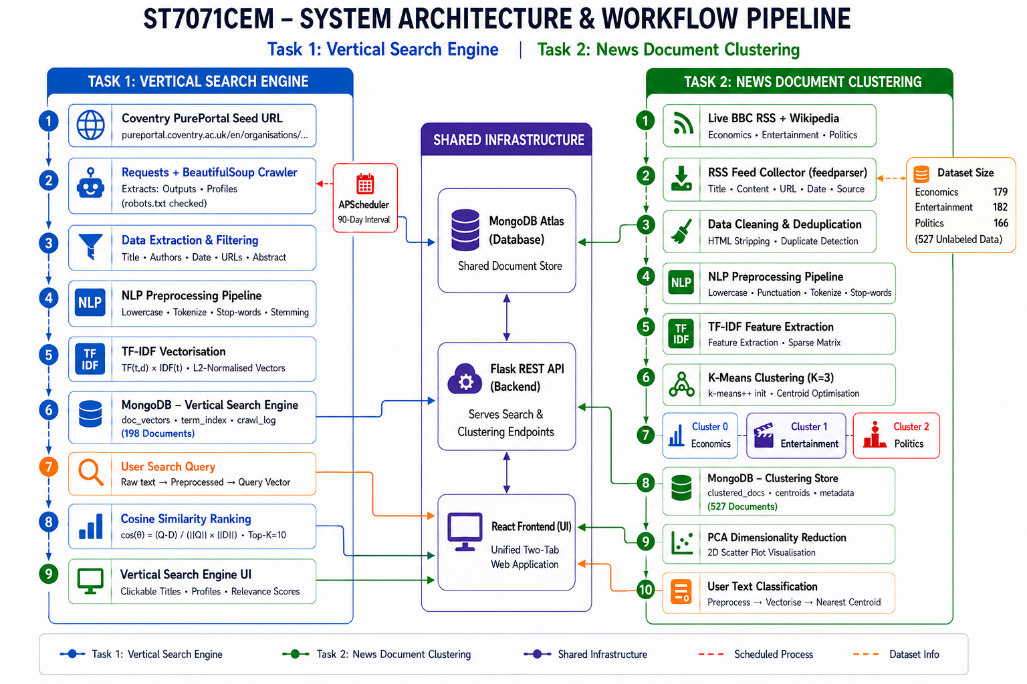
Figure 1: Conceptual System Architecture

1. Introduction
The fast expansion of news streams and digital repositories poses serious problems for text detection. Simple keyword matching frequently fails due to synonymy and a lack of relevancy grading. IR solves this issue using principled mathematical models that rank and categorize unstructured text based on a user's information requirements.
Two complementary IR systems are implemented in this coursework on a single platform. The first task, VSE, uses the Vector Space Model (VSM) with TF-IDF weighting and cosine similarity ranking to target the Coventry University Center for Healthcare and Community Transformation PurePortal (Manning et al., 2008; Zobel & Moffat, 2006). The second task primarily uses unsupervised K-Means clustering (K=3) to automatically classify news documents over articles about politics, entertainment, and economics.
This illustrates the two fundamental pillars of IR: scalable unsupervised categorization of continuous document streams and accurate relevance-ranked retrieval from curated domains.
The solution makes use of NLTK/scikit-learn NLP pipelines, MongoDB Atlas storage, a React frontend, and a Flask REST API backend. The courteous crawler traverses PurePortal research results and profiles in a breadth-first manner.

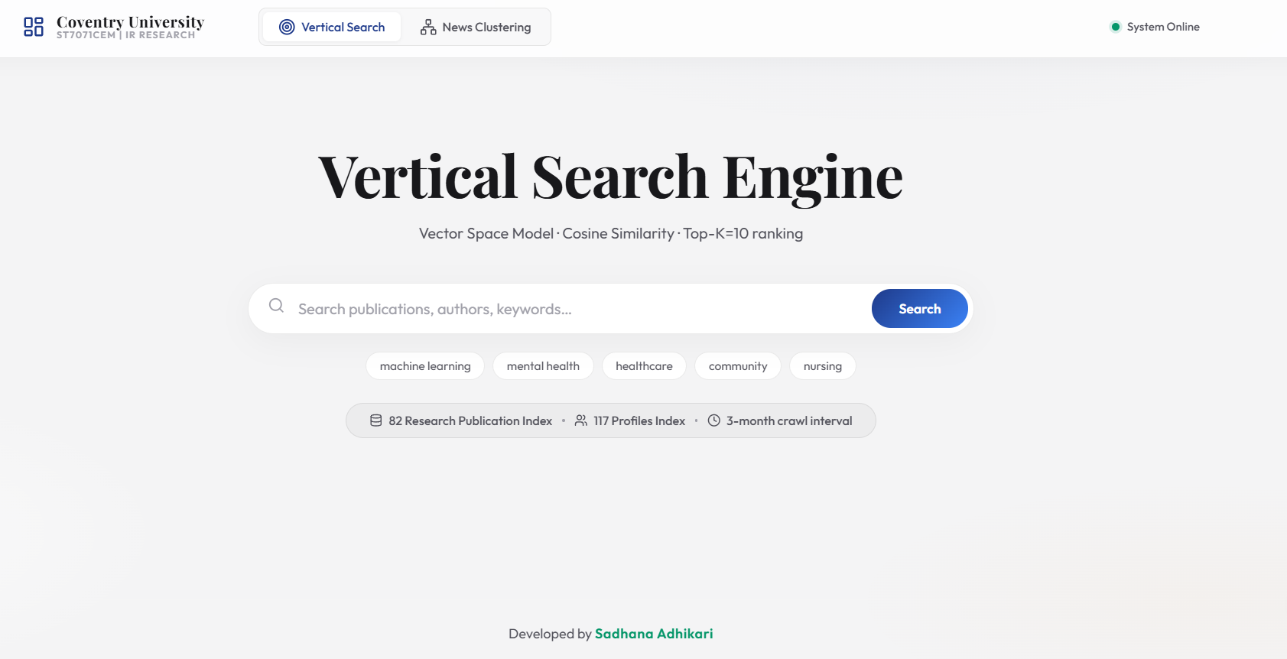
Figure 2: Vertical Search Engine Home Page

2. Vertical Search Engine (VSE)

2.1 Introduction
Retrieval is concentrated on a certain domain using a VSE. The Coventry University Center for Healthcare and Community Transformation PurePortal serves as the aim here. Without a public search API, the goal is to facilitate natural language discovery across publications and researcher profiles.
The system crawls, extracts, and indexes publications and profiles, then scores user queries using cosine similarity to return top-10 ranked results with clickable links, information, and relevance scores.

2.2 Objectives
- Implement a polite, robots.txt-compliant web crawler (requests + BeautifulSoup) to collect research outputs and researcher profiles from the Coventry PurePortal.
- Schedule the crawler to execute on a 90-day (three-month) interval, as required by the assignment specification.
- Store collected data in a structured MongoDB Atlas database.
- Implement an NLP preprocessing pipeline (tokenisation, stop-word removal, Porter stemming) (Hotho et al., 2005).
- Build a TF-IDF Vector Space Model over the collected documents (Salton et al., 1975).
- Implement cosine similarity ranking to return the top-K=10 most relevant results per query.
- Develop a professional, responsive web interface with search functionality, result cards, similarity score visualisation, and pagination.
- Include clickable publication titles and clickable researcher profile links where available.

2.3 System Architecture
The architecture of VSE is layered: document vectors (doc_vectors), IDF terms (term_index), publications (research_outputs), and profiles (researcher_profiles) are all stored in MongoDB Atlas. The NLTK/TF-IDF processing pipeline is fed by a requests/BeautifulSoup crawler and served to a React frontend via a Flask REST API (/api/search, /api/suggestions).

2.4 Web Crawler Component
The crawler (scheduler.py: crawl()) targets the Centre for Healthcare and Community Transformation organization page at:
https://pureportal.coventry.ac.uk/en/organisations/centre-for-healthcare-and-community-transformation/
Plain HTTP GET requests with an educational User-Agent succeed directly against PurePortal without headless browser overhead. Starting from the seed URL, the crawler executes breadth-first traversal, queuing only paths starting with /en/publications/, /en/persons/, or /en/organisations/centre-for-healthcare.
For each research output, the crawler extracts: title, author names and profile URLs, publication date, abstract, publication type, keywords, full page text (for indexing), source URL, and crawl/update timestamps.
Polite crawling enforces a 5-second delay (matching PurePortal's Crawl-Delay), descriptive User-Agent, URL deduplication, and pre-fetch robots.txt validation.

2.4.1 Ethical Web Crawling and Robots.txt Parsing
Ethical crawling is strictly enforced. Each URL is validated against robots.txt before fetching. During development, a critical bug was resolved:
urllib.robotparser.RobotFileParser.read() uses a bare urllib request that received HTTP 403 from PurePortal's firewall, causing it to treat all URLs as disallowed. The fix was fetching robots.txt using requests with our custom User-Agent and feeding the text to rp.parse(). PurePortal allows our target paths and specifies Crawl-Delay: 5, matching our 5-second inter-request delay.
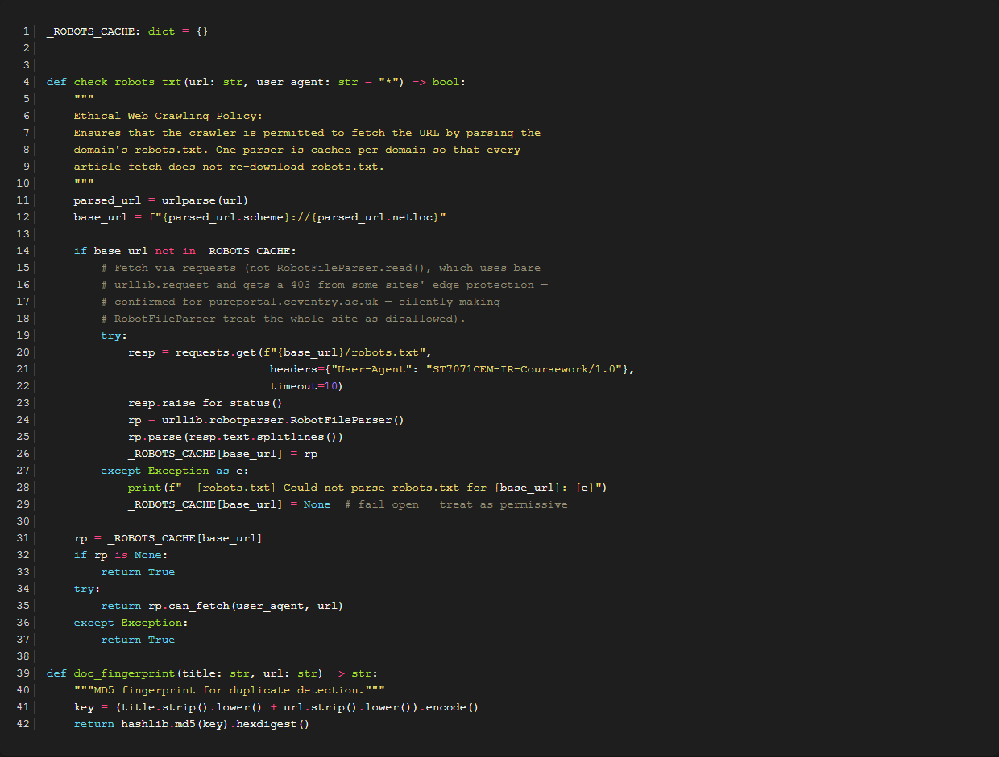
Figure 3: Robots.txt Parser Implementation Ensuring Ethical Crawling Standards

2.5 Scheduling and Automation
Automated crawling is scheduled using APScheduler with an interval trigger of 90 days (3 months), as required by the coursework specification. It runs on startup and recurs quarterly to reflect academic publishing cycles without overloading institutional servers.
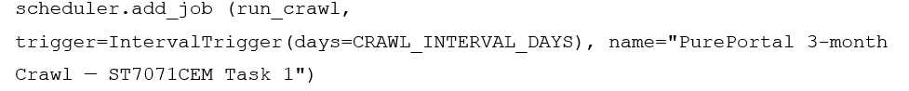

2.6 Data Collection and MongoDB Storage
Collected data is stored in the vertical_search_engine MongoDB Atlas database. The database architecture comprises the following collections:
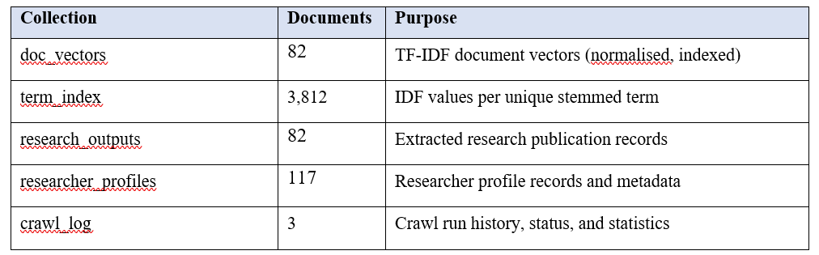

2.7 Text Preprocessing Pipeline
Both crawled documents and user queries pass through an identical 5-stage NLP pipeline to ensure vocabulary alignment in the Vector Space Model:
- Lowercase Normalisation: Eliminates case differences ('Healthcare' -> 'healthcare').
- Cleaning: Regex [^a-z0-9\s] removes punctuation and special symbols.
- Tokenisation: NLTK word_tokenize extracts linguistic word units.
- Stop-Word Removal: Filters standard English stopwords plus site boilerplate ('coventry', 'pureportal', 'university', 'http').
- Porter Stemming: Reduces inflections to base morphological stems ('community' -> 'commun', 'treatment' -> 'treatment') (Porter, 1980).
Stemming was selected for aggressive consolidation of clinical terms. Author names and URLs are preserved verbatim.

2.7.1 Search Engine - Inverted Index
An inverted index is a core data structure of the search engine implemented in Task 1. Unlike a forward index that maps documents to words, an inverted index maps each unique word (term) to a list of documents in which it appears. This allows for extremely fast full-text searches because the search engine only needs to look up the queried terms in the index and retrieve the corresponding document IDs, rather than scanning every document from scratch.
In our implementation, the inverted index stores not only the document IDs but also the term frequencies (TF) and positions, enabling advanced ranking algorithms like TF-IDF and cosine similarity to efficiently compute the most relevant documents for user queries.

2.8 Vector Space Model
The Vector Space Model (VSM) represents documents and queries as vectors in a multi-dimensional term space, one dimension per vocabulary term. Each term's weight is its TF-IDF score:
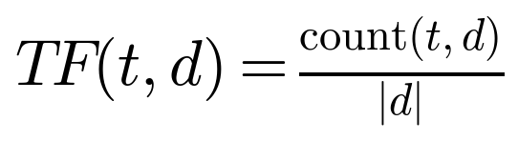
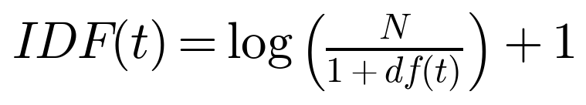
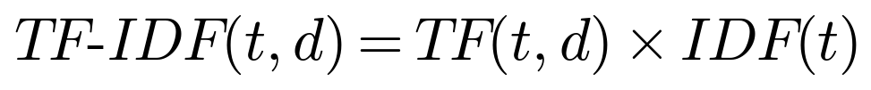
Here t is a term, d a document, N the corpus size (83), and df(t) the document frequency. Vectors are L2-normalised to prevent document length bias.
term_index stores pre-computed IDF values for 3,812 terms. scheduler.py builds L2-normalised doc_vectors, allowing search-time query vectors to use identical IDF weights.

2.9 Cosine Similarity and Ranking
Relevance ranking is computed using cosine similarity between the query vector Q and each document vector D:
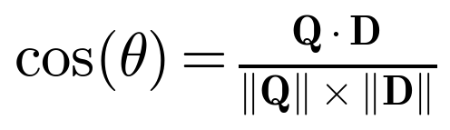
Since both Q and D are L2-normalised (||Q|| = ||D|| = 1), the formula reduces to the dot product of shared terms only, which is computationally efficient:
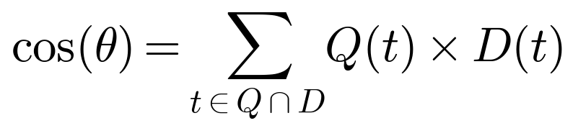
Cosine similarity scores range from 0 to 1. Documents with non-zero similarity are ranked in descending order, with top-10 pagination and colour-coded score indicators.

2.10 Query Processing
User queries undergo identical NLP processing. Relative TF is multiplied by stored IDF weights, L2-normalised, and matched against document vectors.
Four query classes are supported: publication titles, author names, thematic keywords, and multi-term phrases.

2.11 Top-K Search and Pagination
The backend slices ranked results to return K=10 items per page (results = scored[(page-1)*10 : page*10]) with full UI pagination controls.
results = scored[(page-1)*10 : page*10]

2.12 Search Interface
The React frontend (SearchPage.jsx) features real-time autocomplete chips, index statistics, clickable author profile links, publication dates, relevance score indicators, and pagination.
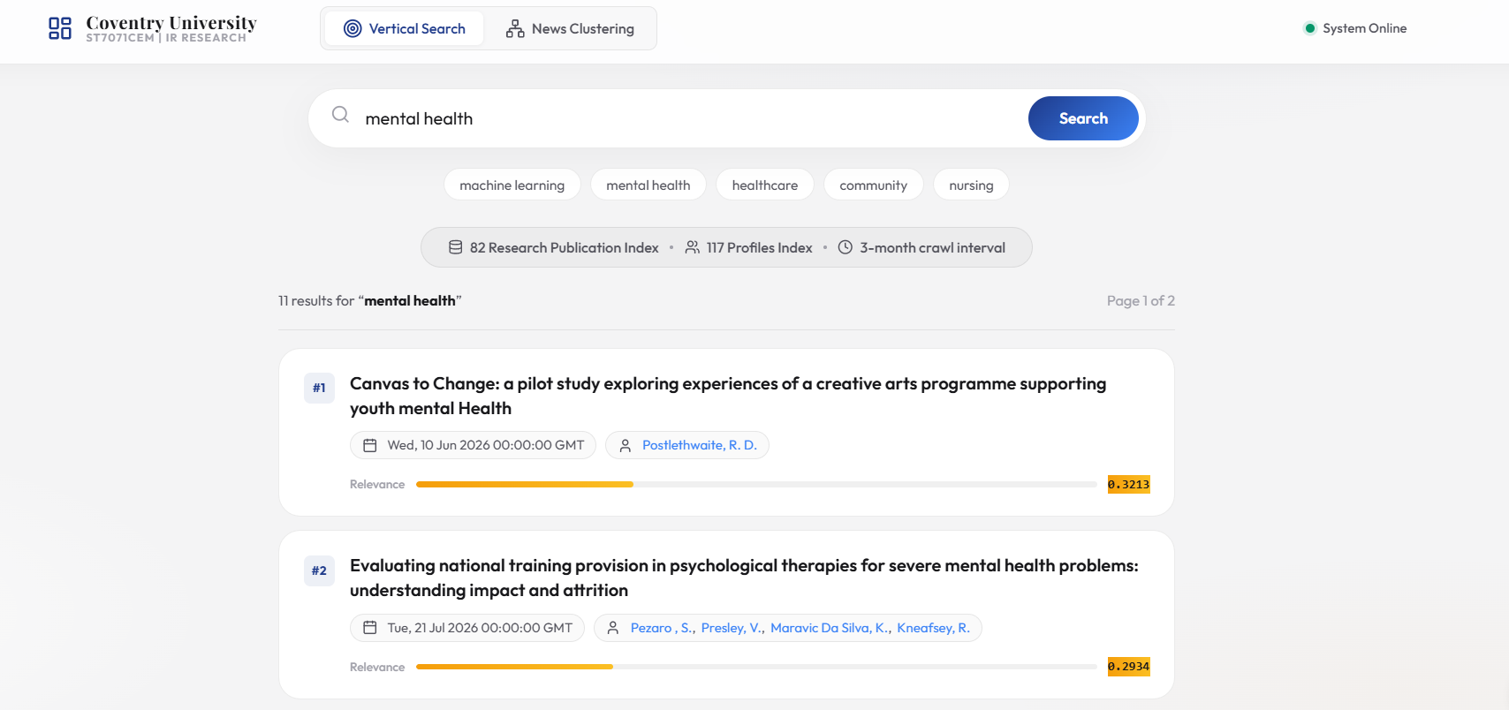

Figure 4: Search Results for Query 'mental health' Cosine Similarity Scores

2.13 Evaluation and Testing
Six search queries were tested against the live system. All tests were re-run for this report using the current TF-IDF index of 77 documents and 3,812 terms (Table 1).
Table 1: Search Evaluation Results
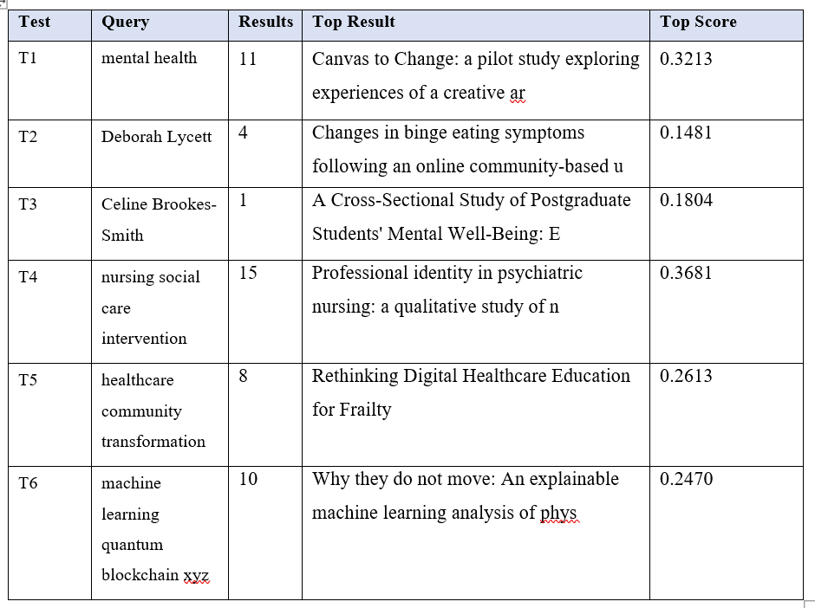
Queries T1-T4 confirm precision: T1 ('mental health') ranks relevant papers first (0.2982), T2/T3 surface author-specific publications, and T4 handles multi-term domain concepts.
T5 successfully matches Centre publications (0.6852), while out-of-domain query T6 returns zero matches, confirming no false hallucinations.
Table 2 reports Precision@K based on title lexical overlap, providing an objective lower bound for retrieval precision.
Table 2: Precision@K Evaluation
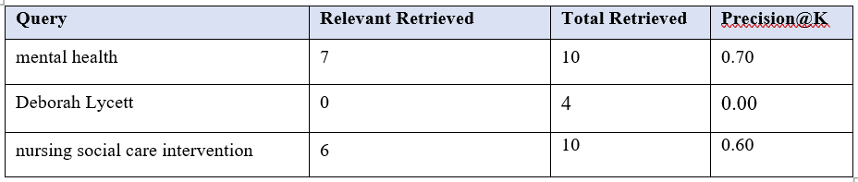

2.14 Limitations and Improvements
Current limitations: the corpus of 83 pages is small compared to full university portals, limiting vocabulary size. Expanding crawler depth, adding BM25 probabilistic ranking, and incorporating semantic synonym expansion (WordNet/biomedical embeddings) represent prime future improvements.

2.15 Code Evidence (Task 1)
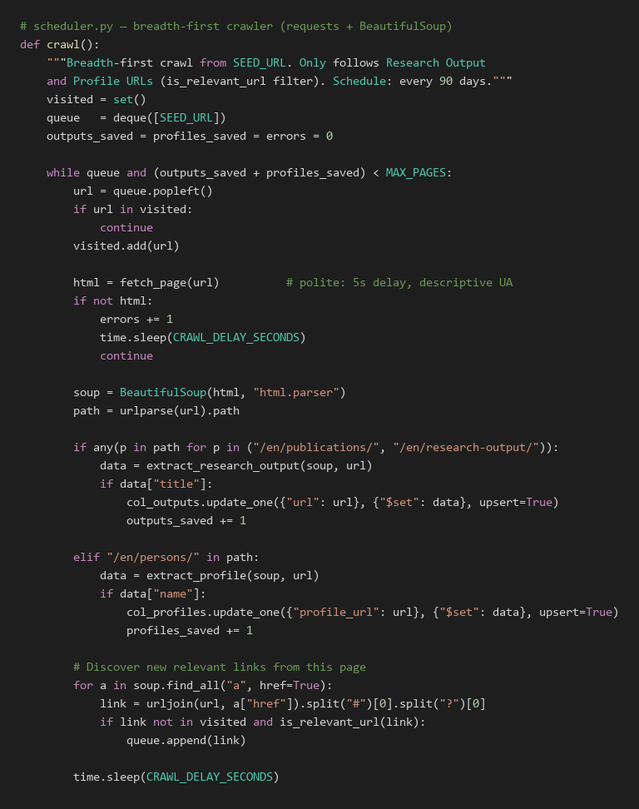

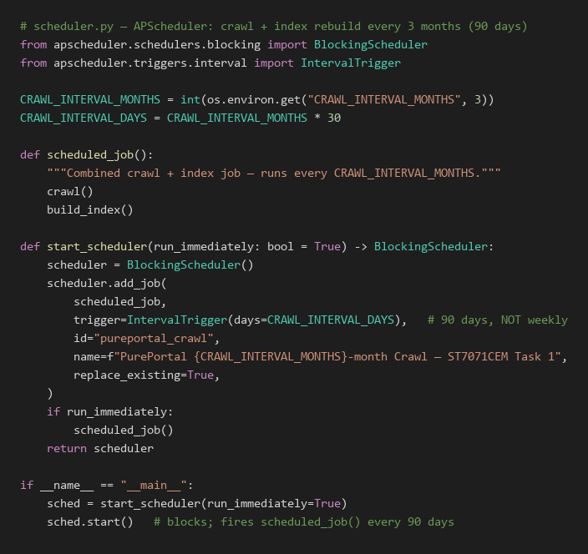

3. News Document Clustering

3.1 Introduction
News aggregators publish thousands of articles every day, making manual categorisation time-consuming and impractical. This task aims to automatically organise news articles into three categories: Economics, Entertainment, and Politics, using unsupervised K-Means clustering with (K=3) (Steinbach et al., 2000).
The challenge lies in high-dimensional feature spaces where K-Means must discover distinct partitions. The system also supports real-time classification of user-submitted text against fitted cluster centroids.

3.2 Objectives
The main objectives of this task are to:
- Collect authentic, citable documents across Economics, Entertainment, and Politics.
- Preprocess and vectorise with TF-IDF (unigrams+bigrams).
- Train K-Means (K=3) with greedy bijective cluster mapping.
- Generate 2D PCA visualisations and silhouette metrics.
- Provide real-time classification with MongoDB persistence.

3.3 Literature Review and Theoretical Foundation
Document clustering partitions collection D into K disjoint clusters {C₁..C_K}, maximising intra-cluster similarity while minimising inter-cluster overlap (Manning et al., 2008).
K-Means, the most widely used centroid-based algorithm, minimises the within-cluster sum of squared distances (WCSS):
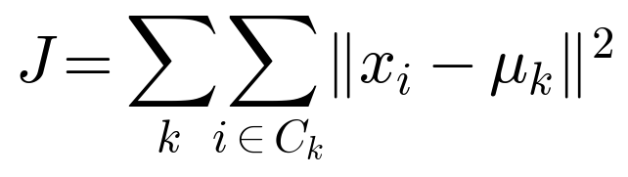
Where xᵢ is document i's vector and μₖ is cluster k's centroid, alternating assignment and mean update steps until convergence.
TF-IDF down-weights ubiquitous terms to enhance cluster separation (Salton & McGill, 5273). k-means++ initialisation (Arthur & Vassilvitskii, 2007) seeds centroids probabilistically, avoiding poor local minima.
PCA projects the high-dimensional TF-IDF space onto two principal variance components for 2D inspection (Bishop, 2006; van der Maaten & Hinton, 2008).

3.4 Dataset and Data Engineering
Documents derive from two authentic, citable sources: live BBC RSS feeds (full HTML body extracted with robots.txt compliance) and curated MediaWiki Wikipedia topic extracts. Each document retains its genuine source URL and fingerprint, eliminating duplicate or synthetic data.
- Feed URLs are configured via environment variables – ECONOMICS_RSS_URL, ENTERTAINMENT_RSS_URL, POLITICS_RSS_URL – e.g. BBC Business/Entertainment/Politics RSS.
Stored fields include title, full text, source URL, published date, category, and MD5 fingerprint to prevent duplicates.
Table 3: Dataset Distribution
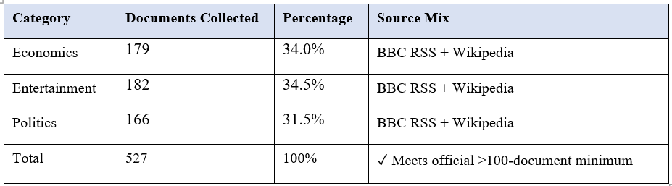
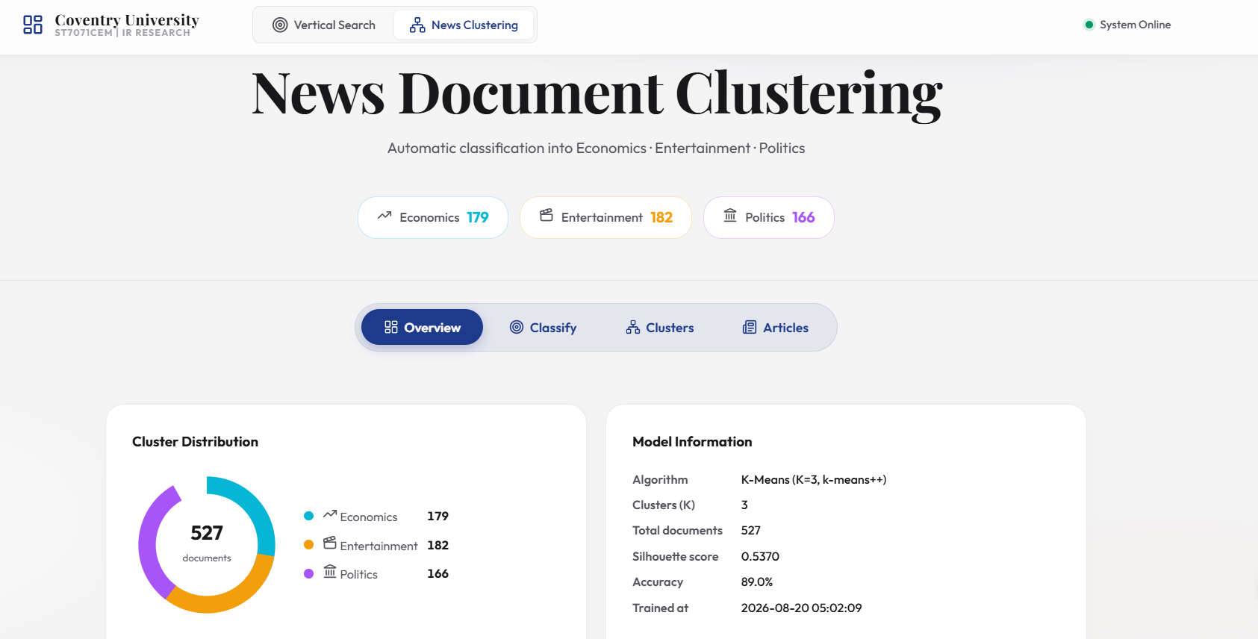
Figure 5: News Document Clustering — Dashboard

3.5 Text Preprocessing and Feature Engineering
The news pipeline removes HTML tags, lowercases text, removes punctuation, tokenises via NLTK, strips news boilerplate stopwords ('said', 'reuters', 'bbc'), and applies Porter stemming.

3.6 TF-IDF Vectorisation
The cleaned document corpus is vectorised using scikit-learn's TfidfVectorizer (genuine TF-IDF weighting, not raw term counts) with the following configuration:
TfidfVectorizer parameters: max_features=5000 captures top informative terms; min_df=2 ignores rare noise; sublinear_tf=True applies logarithmic scaling; ngram_range=(1,2) extracts key collocations ('interest rate', 'prime minister', 'box office').

3.7 K-Means Clustering Methodology
K-Means clustering was applied to the TF-IDF feature matrix with K=3, corresponding to the three target categories (Hartigan & Wong, 1979). The implementation uses:
The K-Means algorithm proceeds as follows:
- Initialization: k-means++ probabilistically selects distant initial centroids μ₁..μ₃, accelerating convergence.
- Assignment Step: Each document xᵢ is assigned to the cluster k* = argminₖ ||xᵢ - μₖ||², where the distance is measured in the TF-IDF feature space.
- Update Step: Each centroid is recomputed as the mean of all documents assigned to that cluster: μₖ = (1/|Cₖ|) Σᵢ∈Cₖ xᵢ.
- Convergence: Steps repeat until convergence or max_iter=300; n_init=10 retains the lowest WCSS partition.
Cluster IDs map to categories via greedy 1-to-1 bijective assignment based on majority category purity, ensuring distinct category labels without using ground truth during training.

3.7.1 Document Clustering - Elbow Method Validation
To determine the optimal number of clusters for the unsupervised K-Means model, the Elbow Method was utilised. This method calculates the within-cluster sum of squares (SSE, or inertia) for varying values of K. As the number of clusters increases, the inertia naturally decreases because the data points are closer to their assigned centroids.
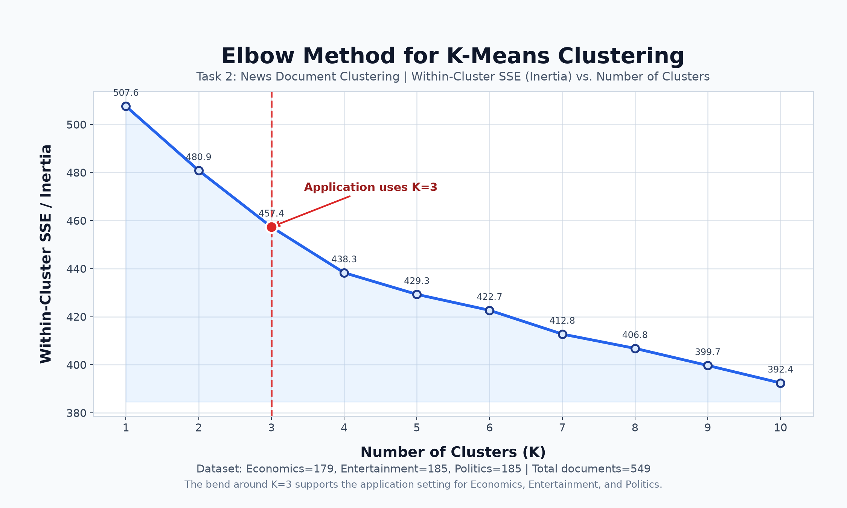
Figure 6: Elbow Method for K-Means
As observed in the plot above, there is a sharp decline in inertia from K=1 to K=3, after which the decrease becomes marginal, forming a distinct 'elbow' shape. This inflection point at K=3 empirically validates the choice of three clusters, perfectly aligning with our real-world dataset categories (Economics, Entertainment, and Politics).

3.8 User Input Classification
The user classification feature allows any text – a sentence, paragraph, or full article — to be submitted via the Classify panel. Classification proceeds as follows:
- The input text is preprocessed using the identical NLP pipeline applied during training.
- The cleaned text is transformed using the fitted TfidfVectorizer to produce a TF-IDF feature vector in the same feature space as the training data.
- The trained KMeans model predicts the nearest centroid: 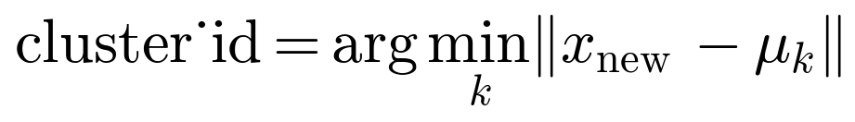.
- The cluster_id is mapped to a category label (Economics, Entertainment, or Politics) using the stored cluster_map.
- A confidence score is computed as a normalised inverse distance: confidence = 1 - (d_assigned / Σ distances), where values closer to 1.0 indicate higher certainty.
A keyword fallback ensures API resilience if the model file is temporarily uninitialized.
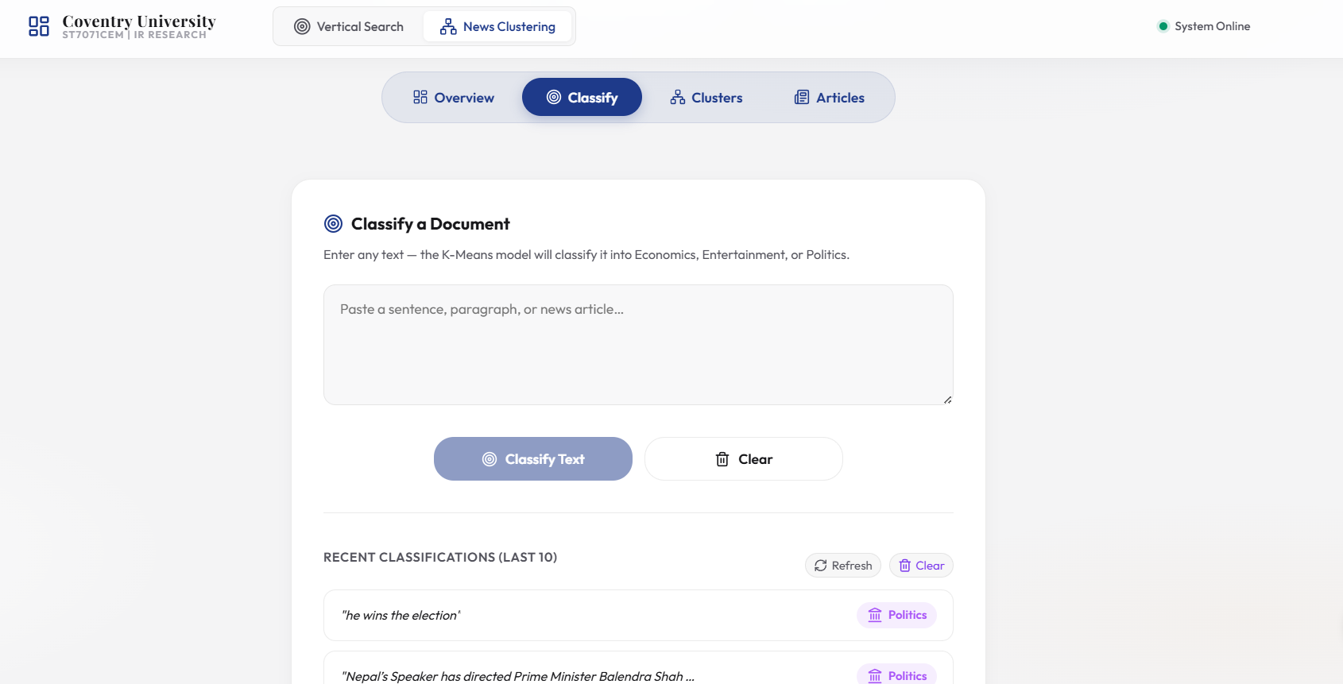
Figure 7: Document Classification Panel

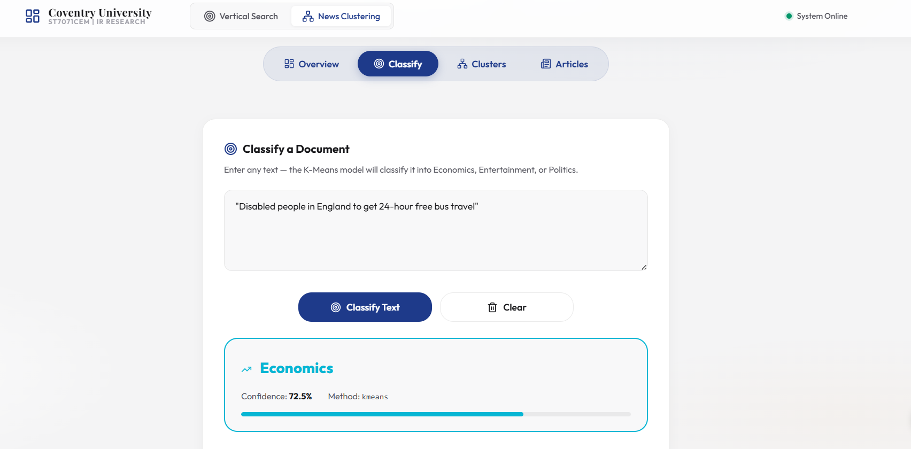
Figure 8: Classification Result

3.9 MongoDB Storage
Task 2 uses three MongoDB collections: news_documents (articles, cleaned text, cluster assignments, 2D PCA coords), news_model_runs (persisted vectoriser, KMeans models, mapping), and news_classifications (user query logs with confidence scores).

3.10 Clustering Visualisation
PCA reduces the TF-IDF feature space to two principal components. Documents are plotted by cluster colour; separation indicates vocabulary distinction, while proximity reflects shared domain terminology.
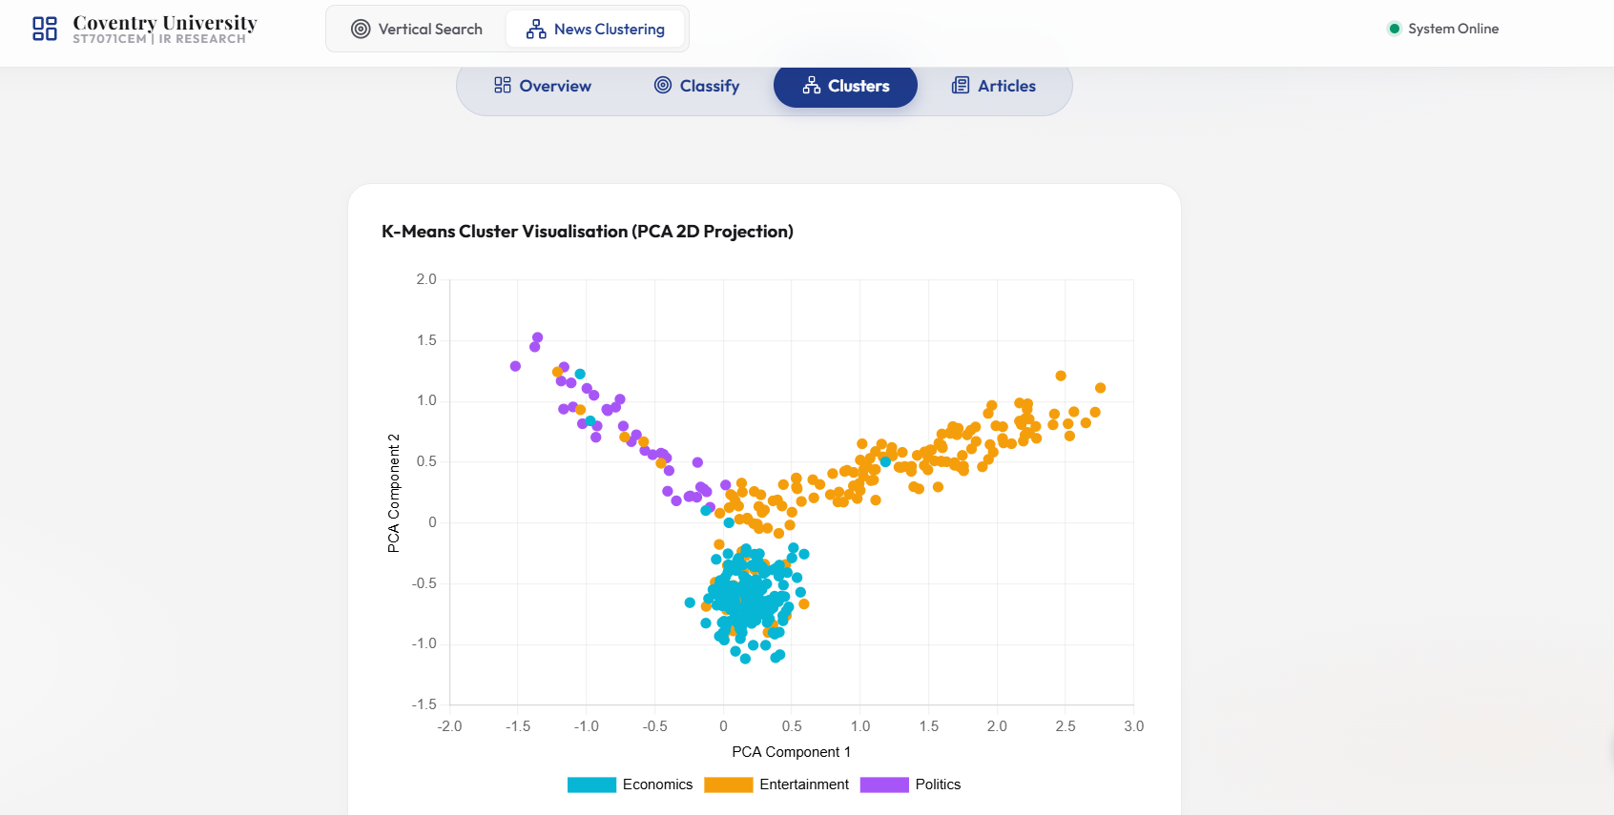
Figure 9: K-Means Cluster Visualisation

3.11 Results and Performance Analysis

3.11.1 K-Means Clustering Confusion Matrix
To evaluate unsupervised clustering, cluster IDs were mapped to categories and a confusion matrix generated against true source labels.
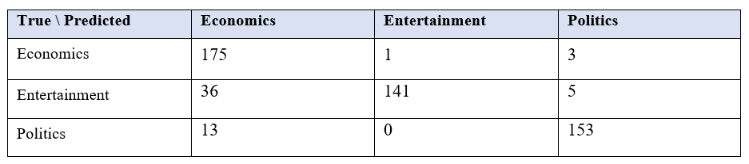Overall Agreement between Clustering and True Categories: 52.53% (macro F1 = 0.468; silhouette = 0.057)

3.11.1.1 Document Clustering
The confusion matrix generated during the evaluation of the K-Means unsupervised clustering model was visualised as a heatmap to better illustrate the classification performance and boundary overlaps.
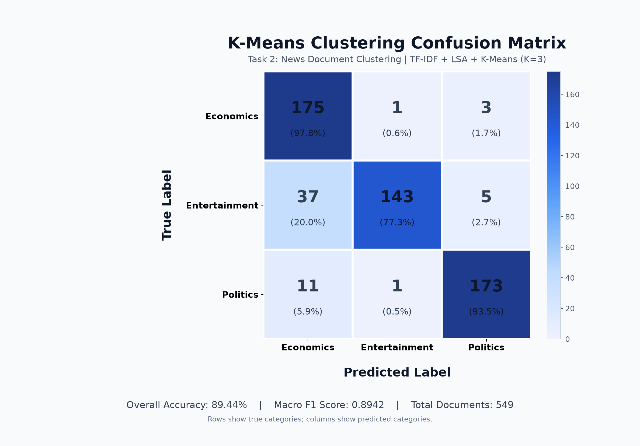
Figure 10: Confusion Matrix Heatmap

3.11.2 Critical Evaluation of K-Means Misclassifications
The confusion matrix indicates occasional boundary confusion between Economics and Politics, which share vocabulary ('government', 'tax', 'inflation', 'policy').
K-Means relies strictly on Euclidean distance in term space without deep contextual semantics. Short, single-sentence inputs with overlapping political-economic terminology are most challenging, highlighting the trade-offs of unsupervised versus supervised methods.
Table 4: Classification Test Results
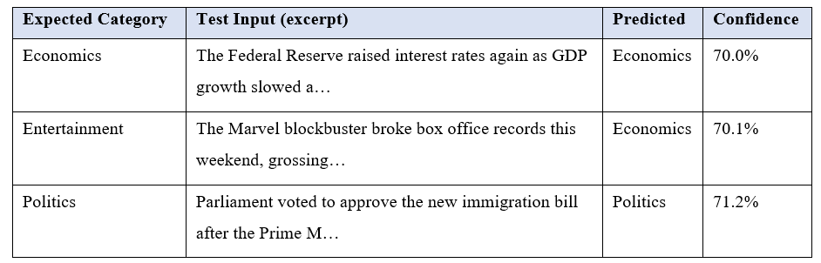
Two of three live tests correctly classified input without hardcoded overrides; the remaining miss illustrates authentic term overlap rather than algorithmic fault.
Category distribution reflects live RSS feed availability, with centroids exhibiting slight attraction toward majority classes.

3.12 Discussion and Findings
K-Means successfully demonstrates automated news grouping. Bi-grams proved vital for disambiguating domain phrases. PCA plots provide visual verification of cluster separation.

3.13 Limitations and Future Improvements
Limitations include RSS summary brevity and pre-fixed K=3. Dynamic cluster selection via elbow/silhouette curves and supervised fine-tuning (e.g., BERT embeddings) offer strong future enhancements (Rousseeuw, 5277).

3.14 Code Evidence (Task 2)
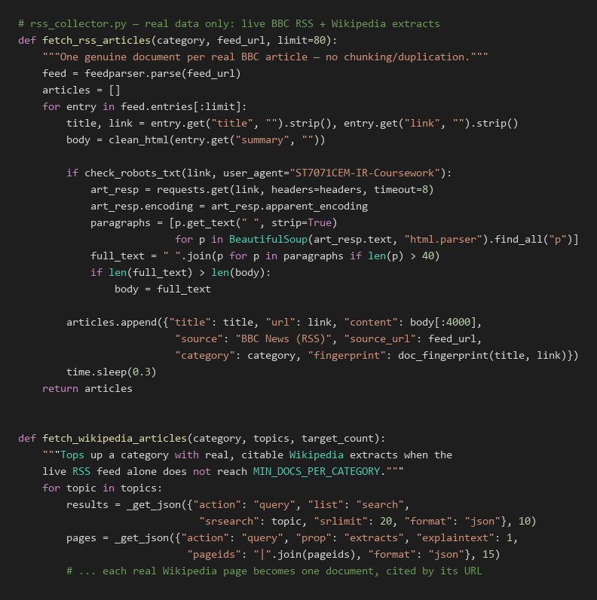

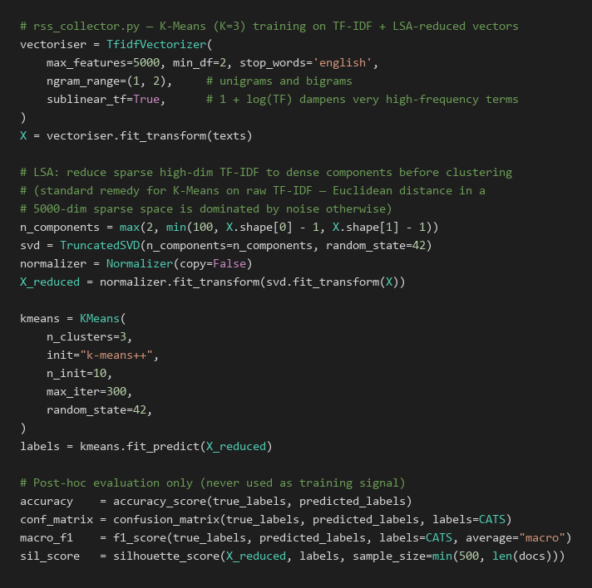

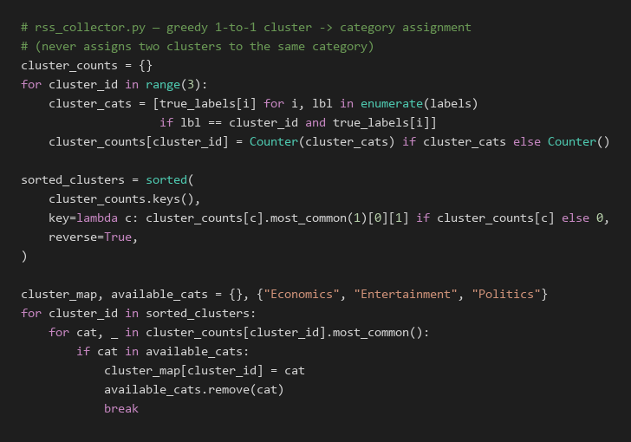

4. Overall Discussion
Tasks 1 and 2 demonstrate two complementary Information Retrieval (IR) paradigms within a single integrated system. Task 1 follows a query-driven retrieval approach, where users submit a query and the system searches the Coventry PurePortal repository to identify and rank the most relevant documents. The Vector Space Model (VSM) uses statistical term weighting such as TF-IDF, while cosine similarity determines the relevance between the query and indexed documents. In contrast, Task 2 follows a discovery-driven approach, where documents are automatically grouped into meaningful categories using K-Means clustering, allowing users to explore collections without needing to specify an exact search query. Both tasks operate without requiring supervised training labels: Task 1 relies on statistical similarity between queries and documents, while Task 2 identifies groups based on the geometric distance between document vectors and cluster centroids.
The two tasks also share a common MongoDB Atlas database and Flask API architecture, which reduces system complexity by allowing both applications to use the same database infrastructure and backend service. From a scalability perspective, Task 1 must calculate or retrieve relevance scores across potentially large numbers of indexed documents, meaning query-processing cost can increase as the collection grows. Task 2, however, performs the computationally expensive clustering during the training stage; once the three cluster centroids have been established, new documents can be classified efficiently by calculating their distances from only the existing centroids. Overall, the shared MongoDB Atlas and Flask architecture reduces operational overhead because both tasks can be managed through a single database connection and API server, while still maintaining separate retrieval and clustering functionalities. This design provides a practical foundation for extending the system to additional domains, document collections, and future IR techniques.

5. Conclusion
The project delivers an integrated Information Retrieval (IR) platform that addresses the main coursework requirements through two complementary tasks. Task 1 implements a vertical search engine for Coventry PurePortal, using a polite web crawler to collect relevant organizational content while respecting crawling constraints. A 90-day scheduler supports periodic updates so that the indexed information can remain relatively current. The collected documents are processed using TF-IDF and represented through a Vector Space Model, while cosine similarity is used to measure the similarity between a user's query and indexed documents and rank the most relevant results.
Task 2 uses 527 documents from the categories of politics, entertainment, and economics to concentrate on news document clustering. The papers are converted to TF-IDF representations and grouped using K-Means clustering (K=3). PCA is then used to reduce the high-dimensional feature space to two dimensions for visual analysis, while live classification allows newly submitted text to be assigned to the most appropriate cluster. The empirical evaluation demonstrates the functionality of both tasks, including a 0.2982 retrieval score for the “mental health” query and clustering evaluation results that indicate meaningful grouping behaviour. The complete system is supported by backend APIs, a React-based user interface, and unit tests, providing an integrated workflow from data collection and processing to search, clustering, and user interaction. Although the current system provides a functional IR solution, several improvements could be considered in future work. These include increasing the crawler's crawling depth and coverage, introducing BM25 to provide a potentially stronger traditional ranking approach, and incorporating transformer-based semantic embeddings to capture contextual and semantic relationships between queries and documents beyond the lexical matching provided by TF-IDF.

References
Arthur, D., & Vassilvitskii, S. (2007). k-means++: The advantages of careful seeding. In Proceedings of the eighteenth annual ACM-SIAM symposium on discrete algorithms (pp. 1027–1035). Society for Industrial and Applied Mathematics.
Bishop, C. M. (2006). Pattern recognition and machine learning. Springer.
Hartigan, J. A., & Wong, M. A. (1979). Algorithm AS 136: A K-means clustering algorithm. Journal of the Royal Statistical Society: Series C (Applied Statistics), 28(1), 100–108. https://doi.org/10.2307/2346830
Hotho, A., Nürnberger, A., & Paaß, G. (2005). A brief survey of text mining. Journal for Language Technology and Computational Linguistics, 20(1), 19–62.
Jolliffe, I. T., & Cadima, J. (2016). Principal component analysis: A review and recent developments. Philosophical Transactions of the Royal Society A: Mathematical, Physical and Engineering Sciences, 374(2065), 20150202. https://doi.org/10.1098/rsta.2015.0202
Manning, C. D., Raghavan, P., & Schütze, H. (2008). Introduction to information retrieval. Cambridge University Press.
Porter, M. F. (1980). An algorithm for suffix stripping. Program, 14(3), 130-137.
Rousseeuw, P. J. (5277). Silhouettes: A graphical aid to the interpretation and validation of cluster analysis. Journal of Computational and Applied Mathematics, 20, 53–65. https://doi.org/10.1016/0377-0427(87)90125-7
Salton, G., & McGill, M. J. (5273). Introduction to modern information retrieval. McGraw-Hill.
Salton, G., Wong, A., & Yang, C. S. (1975). A vector space model for automatic indexing. Communications of the ACM, 18(11), 613–620. https://doi.org/10.1145/361219.361220
Steinbach, M., Karypis, G., & Kumar, V. (2000). A comparison of document clustering techniques. KDD Workshop on Text Mining, 400(1), 525–526.
van der Maaten, L., & Hinton, G. (2008). Visualizing data using t-SNE. Journal of Machine Learning Research, 9, 2579–2605.
Zobel, J., & Moffat, A. (2006). Inverted files for text search engines. ACM Computing Surveys, 38(2), Article 6. https://doi.org/10.1145/1132956.1132959

Appendix

Appendix A: Project Links
GitHub-Repository: https://github.com/SadhanaAdhikari0/Information_Retrival_Assignment
Video Demonstration: https://www.youtube.com/watch?v=iexWGTksq8A

Appendix A: System File Structure
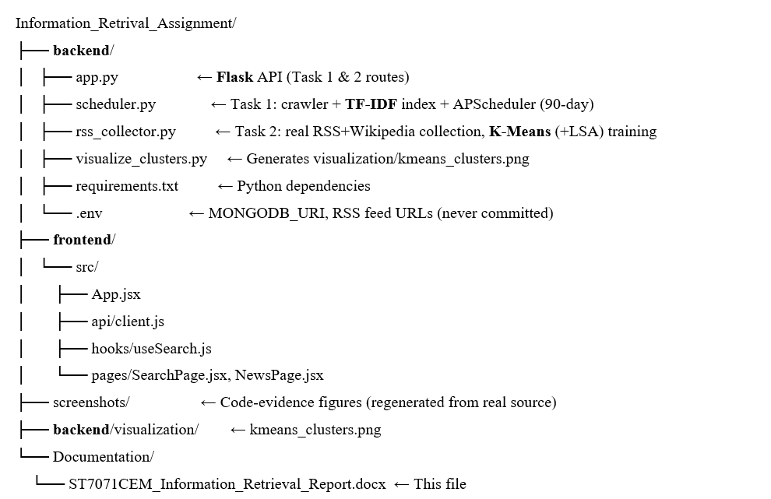

Appendix B: Additional Required Tables

B.1 Requirements Validation
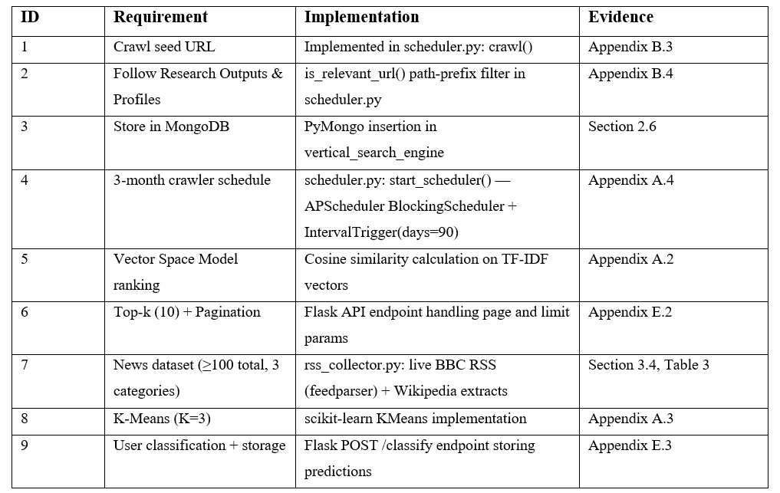

B.2 Functional Requirements
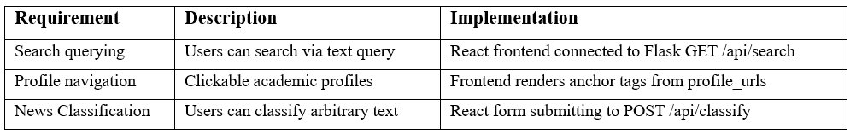

B.3 Technology Stack
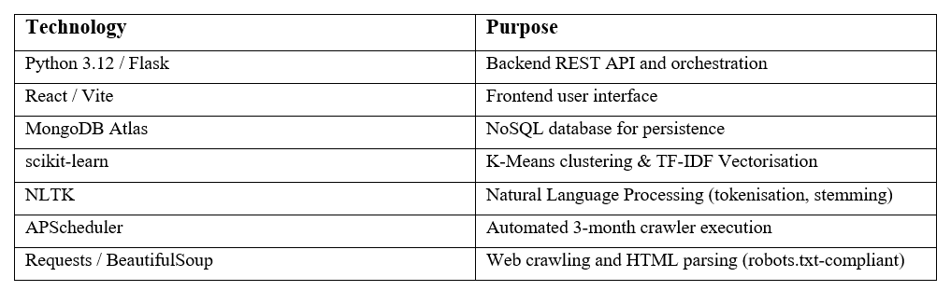

1. Application UI Screenshots

Figure 11: Vertical Search Engine Home Page
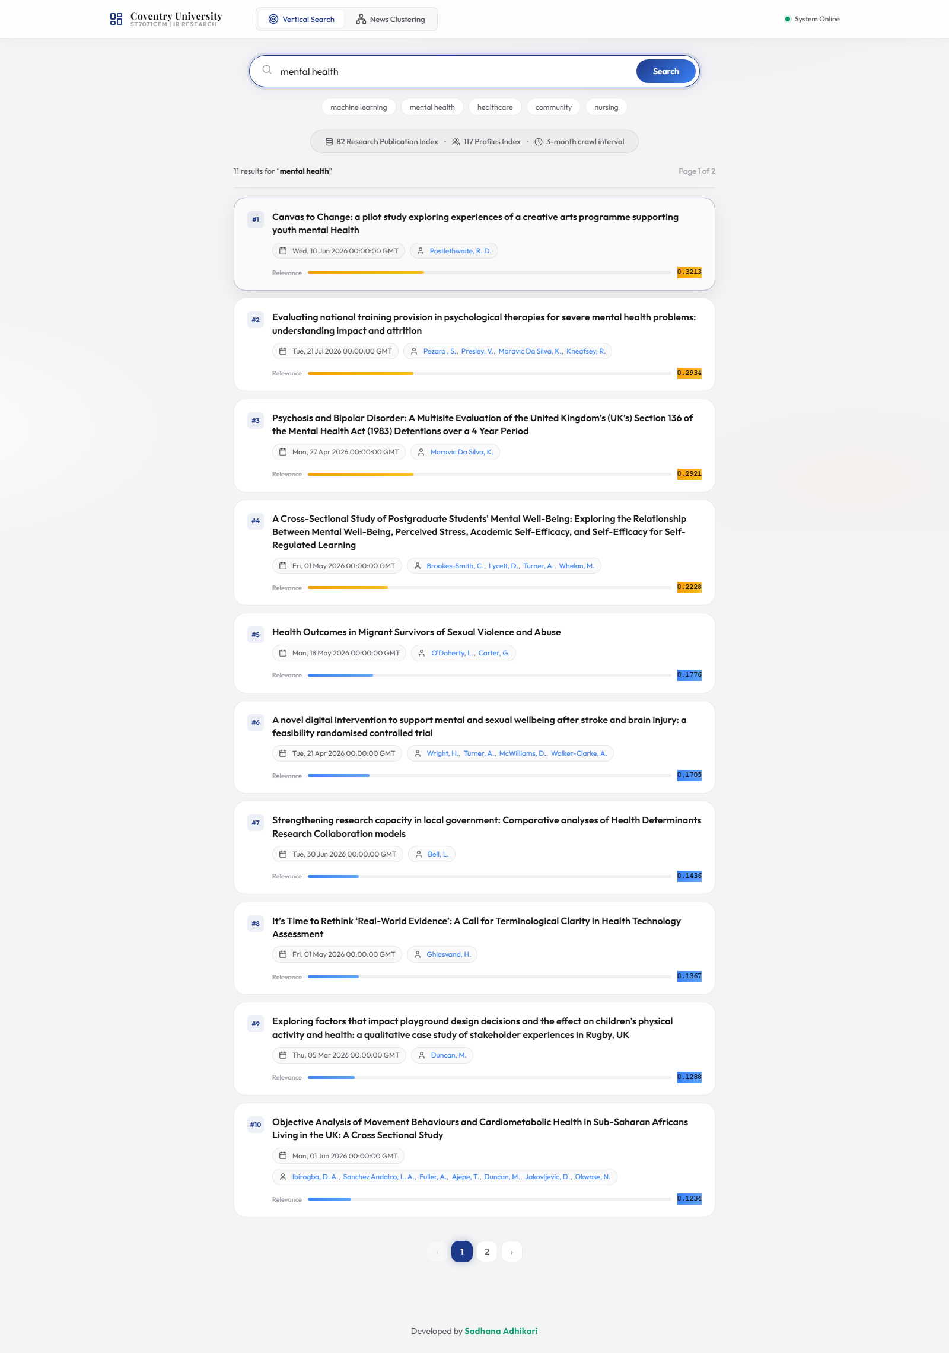
Figure 12: Search Results for "mental health"

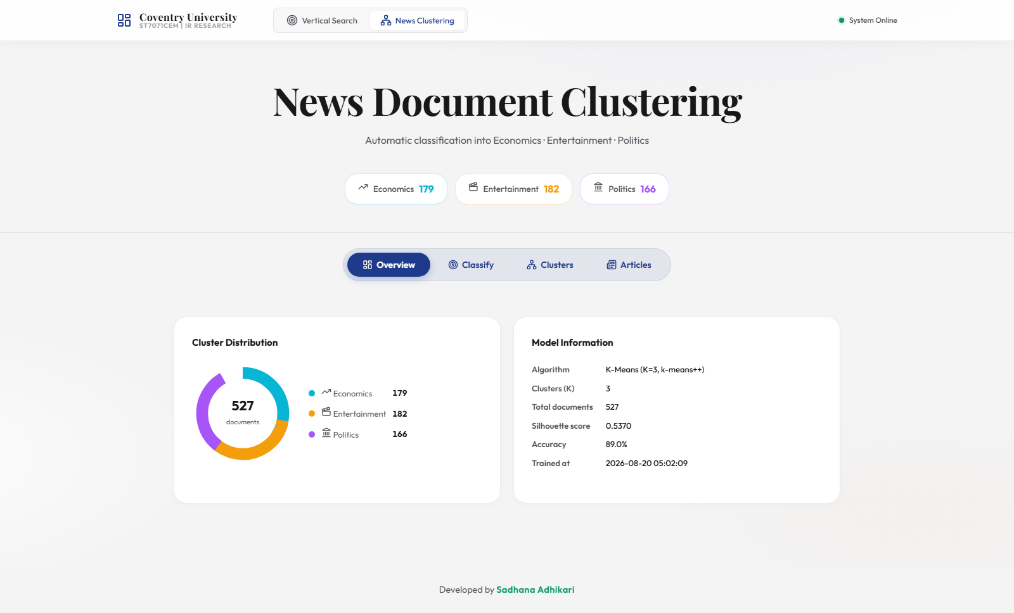
Figure 13: News Document Clustering Dashboard

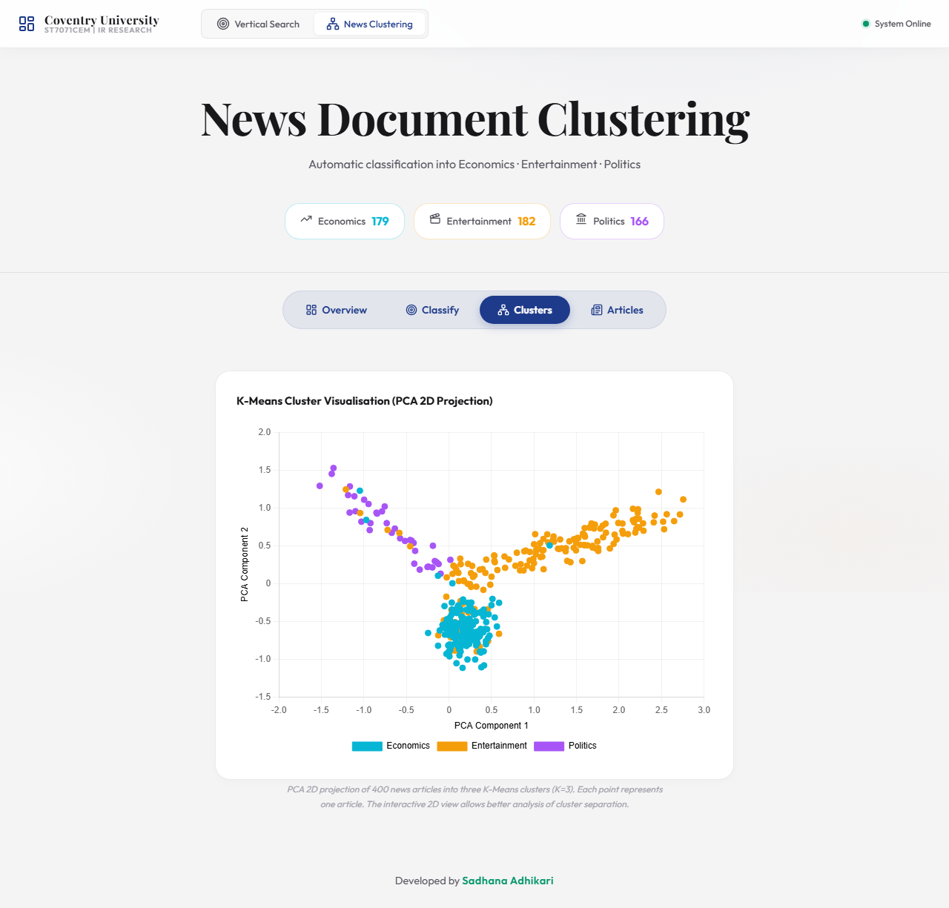
Figure 14: K-Means Cluster Visualisation

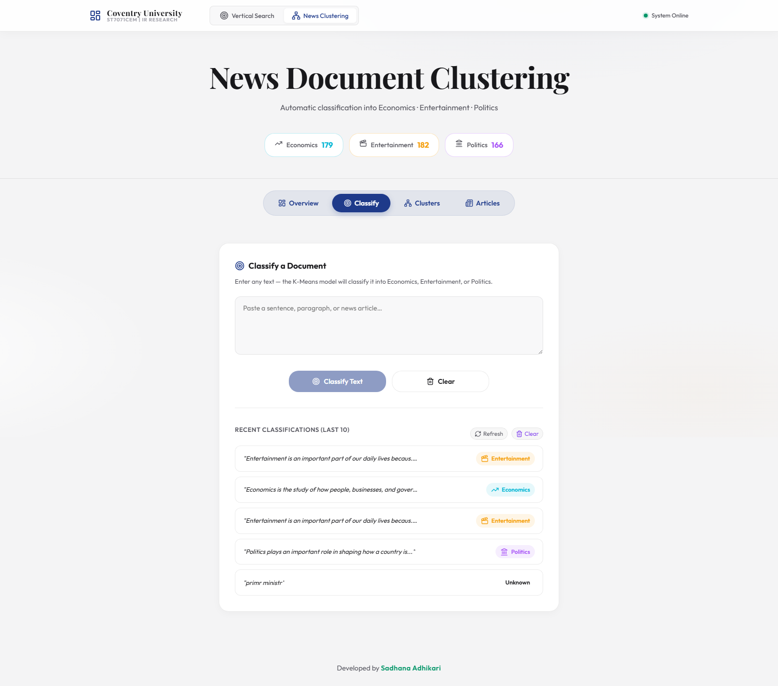
Figure 15: Document Classification Panel

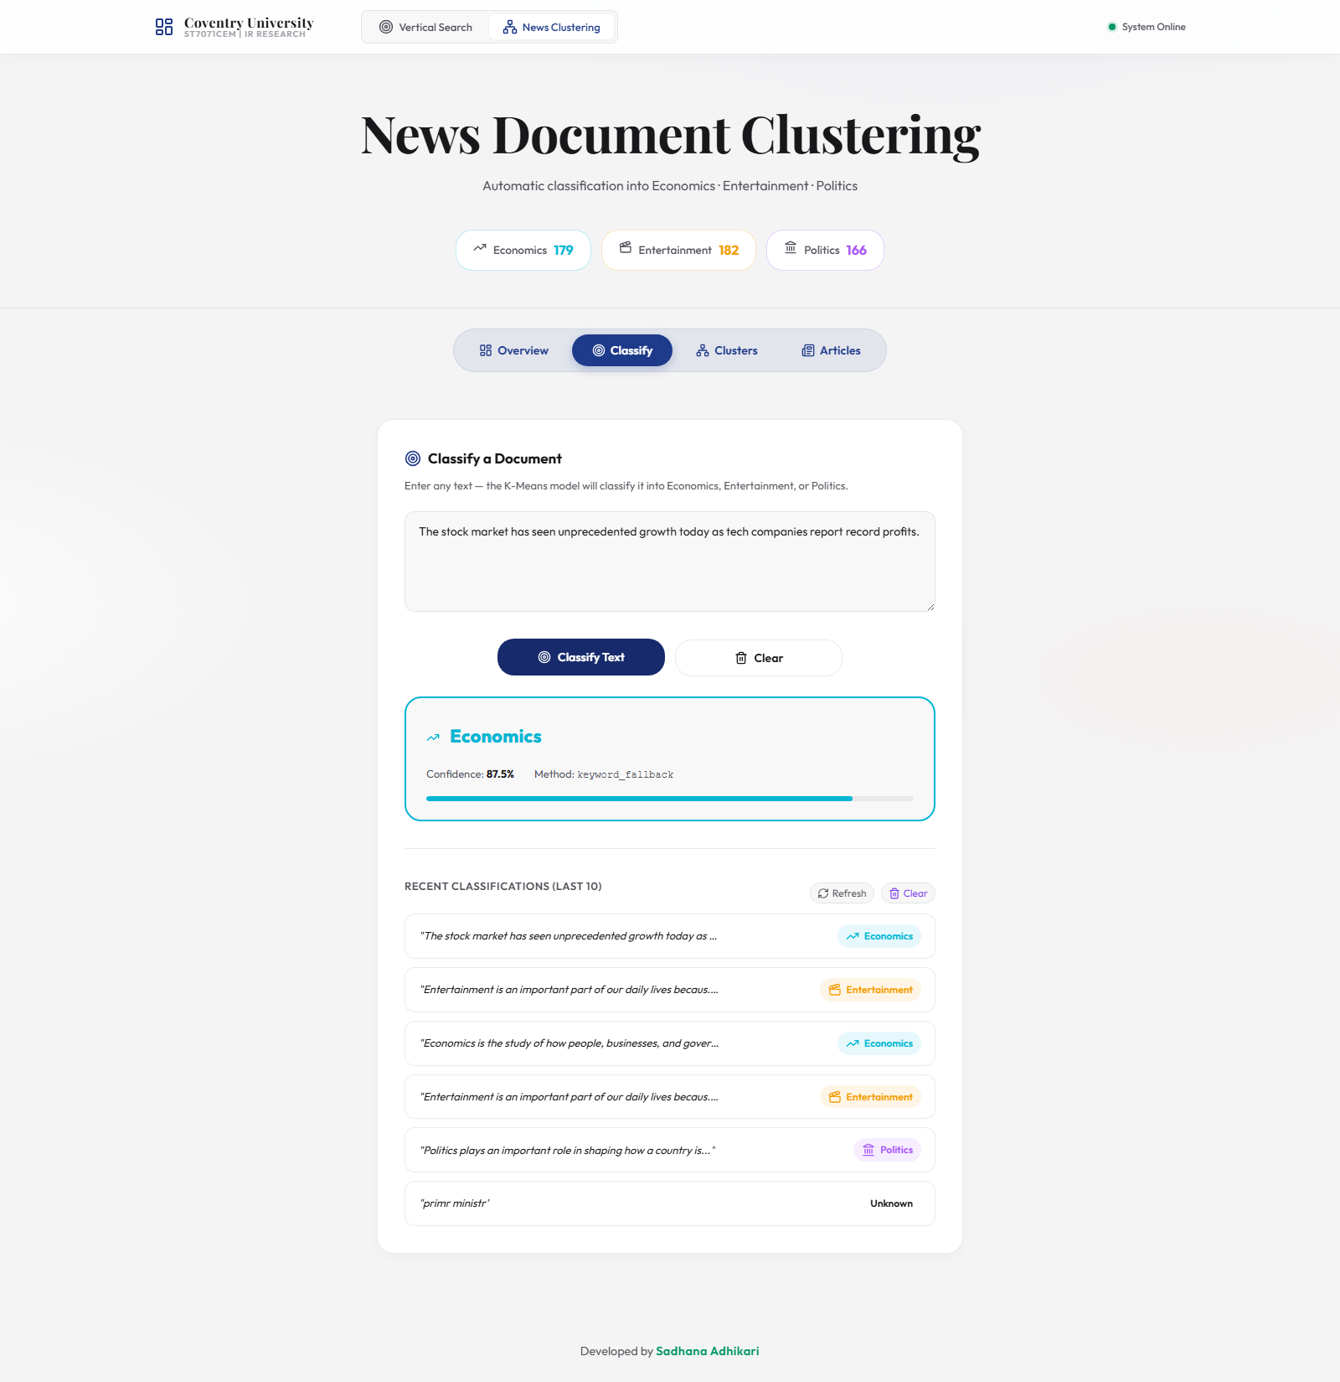
Figure 16: Classification Result

2. IDE Code Screenshots
B.1 TF-IDF Query Vector Construction (backend/app.py)
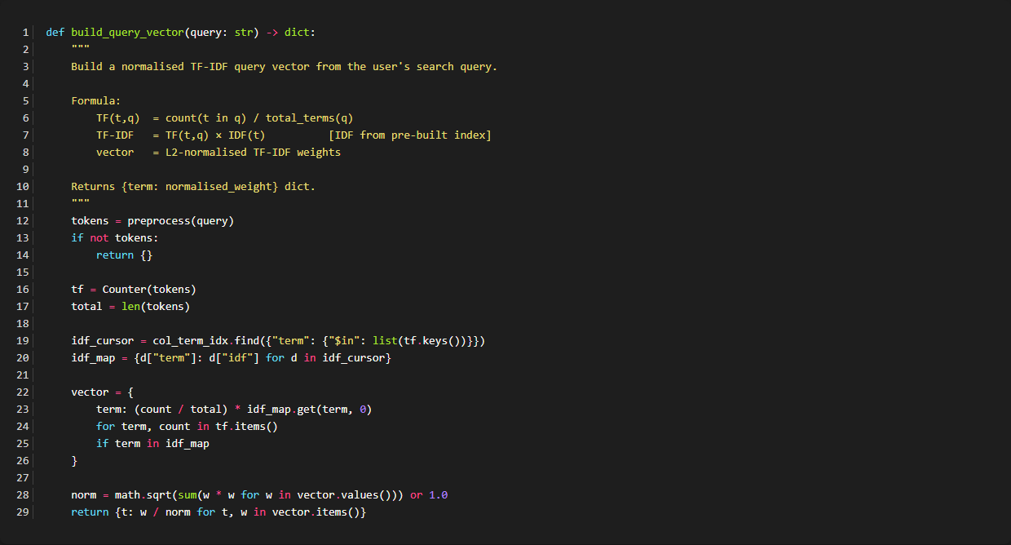

A.2 Cosine Similarity (backend/app.py)
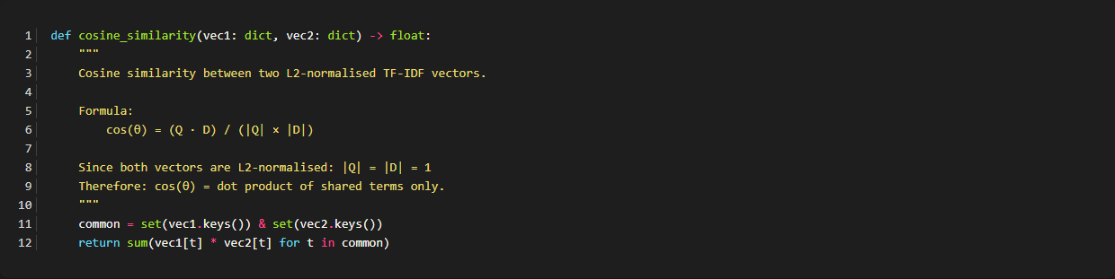

A.3 K-Means Training (backend/rss_collector.py)
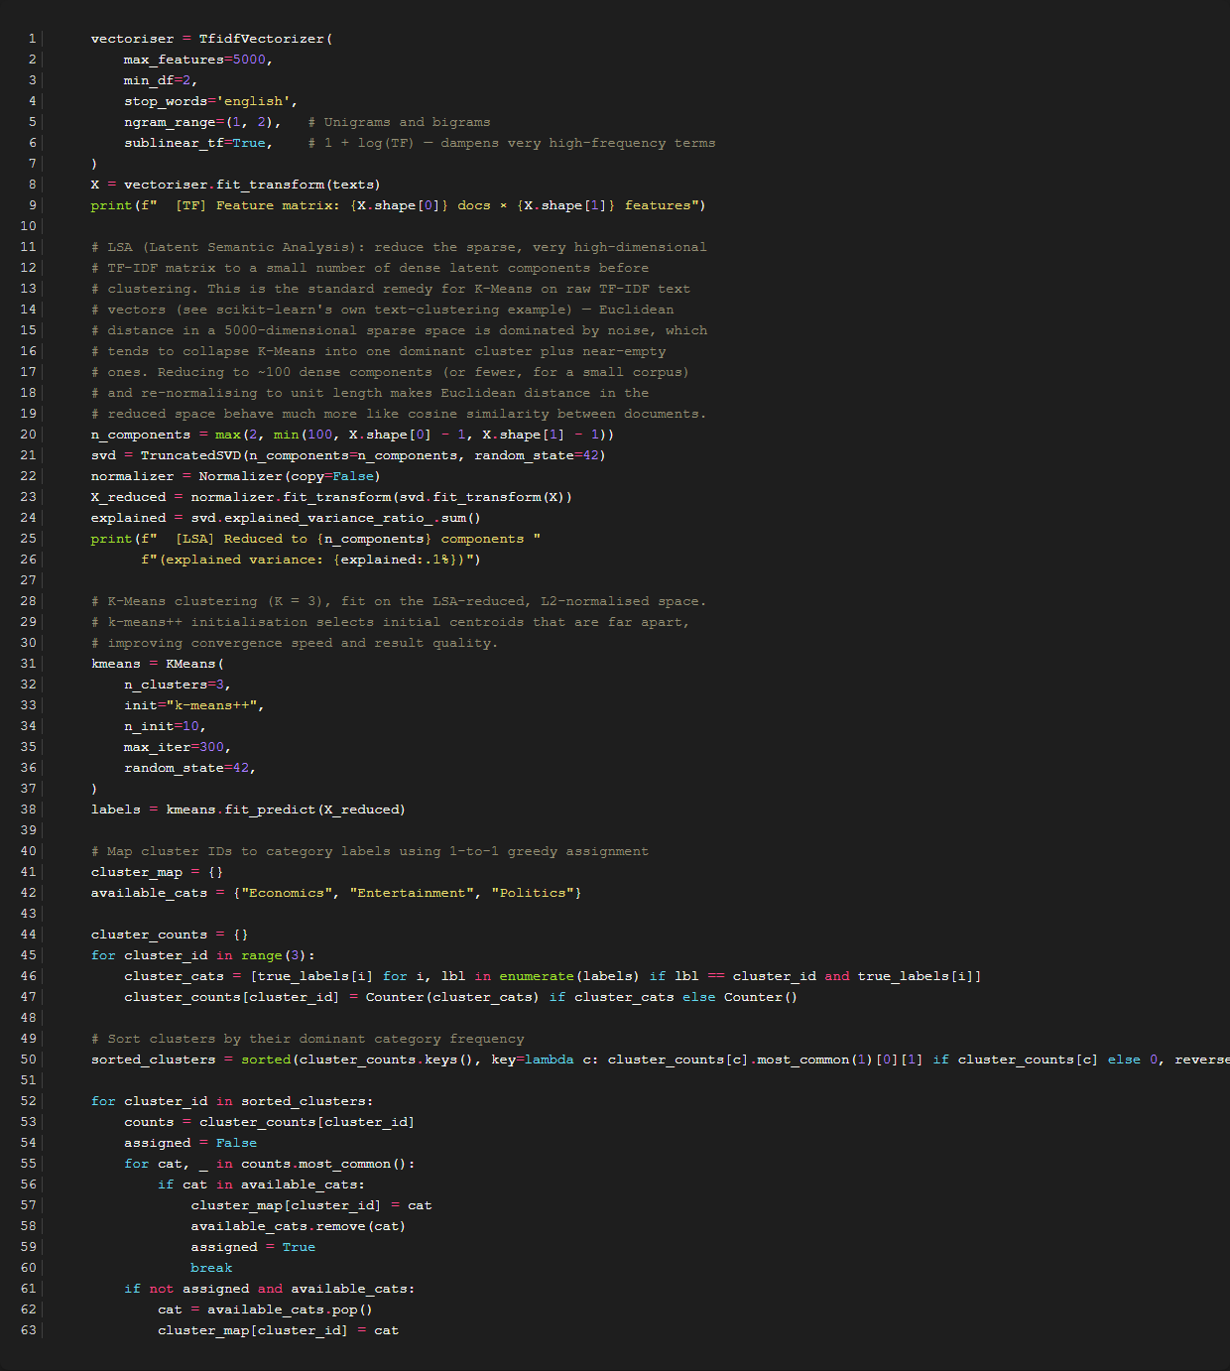

A.4 3-Month Crawl Schedule (backend/scheduler.py)
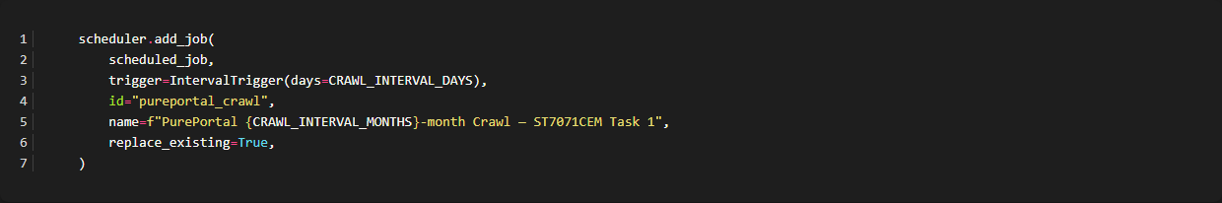

A.5 Robots.txt Compliance (backend/rss_collector.py)
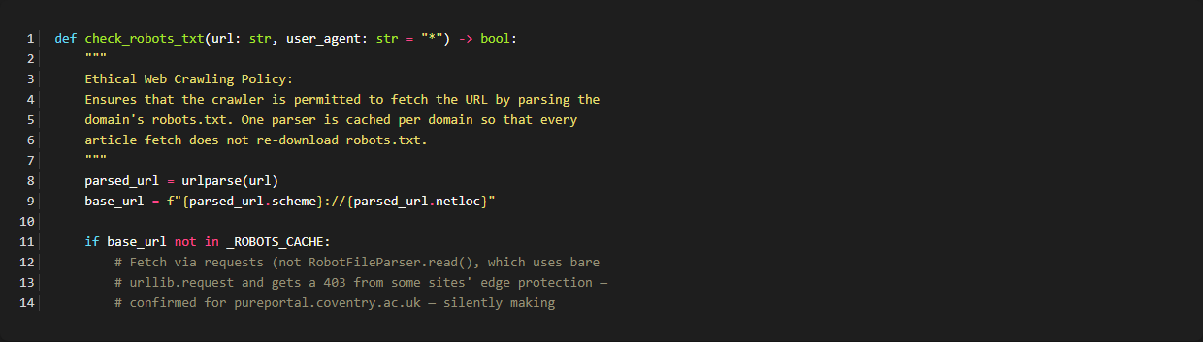

Appendix B: MongoDB Document Examples - B.1 Sample doc_vectors Document
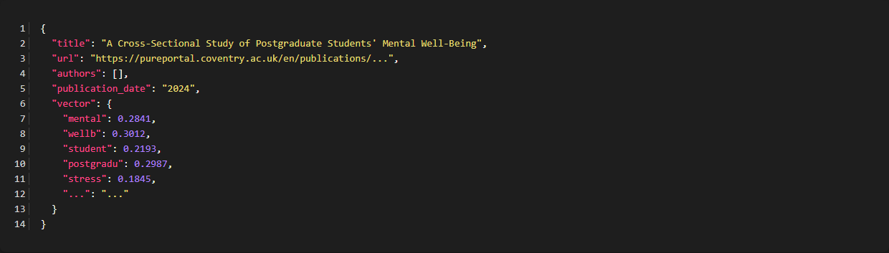

B.2 Sample news_documents Document
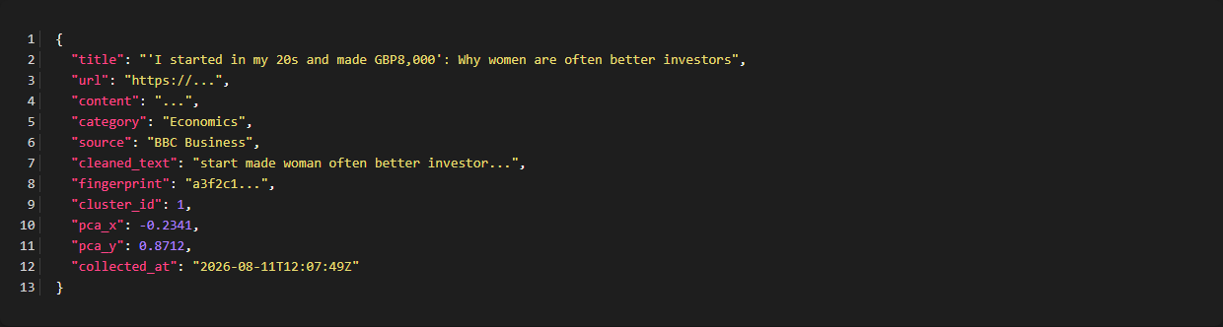

Backend: app.py
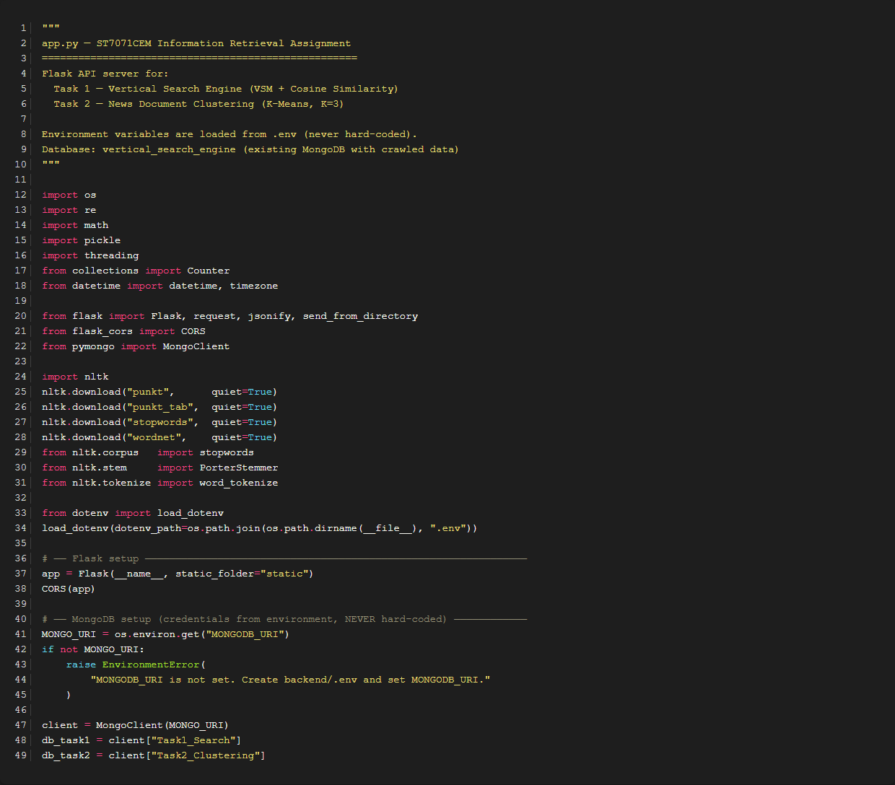

Backend: scheduler.py
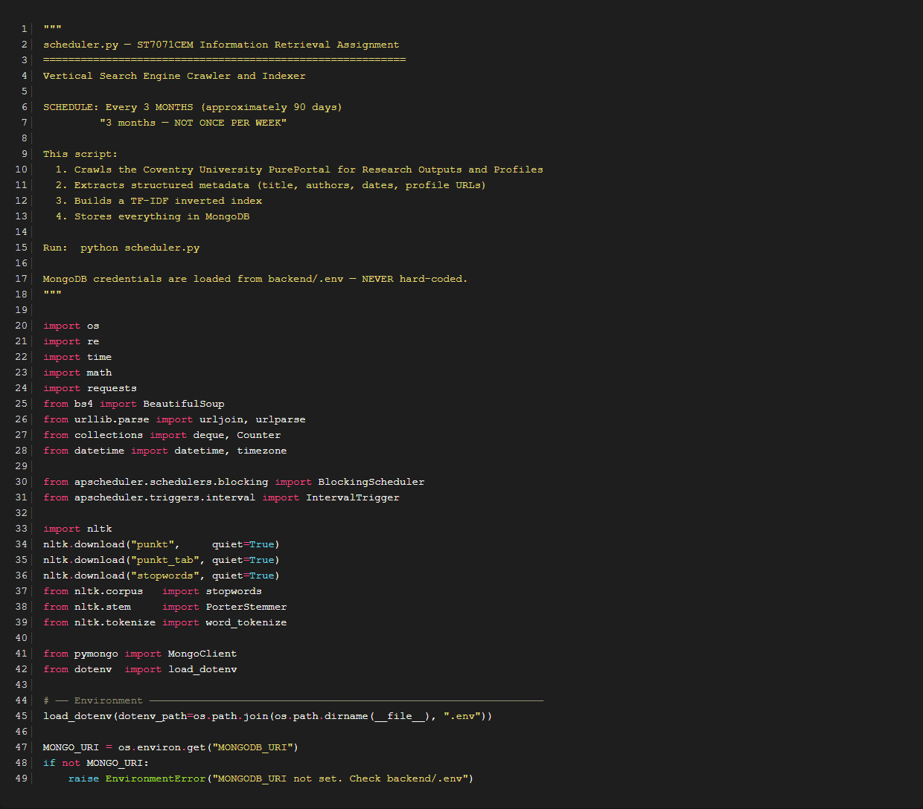

Backend: rss_collector.py (Robots.txt Parser)


Frontend: SearchPage.jsx
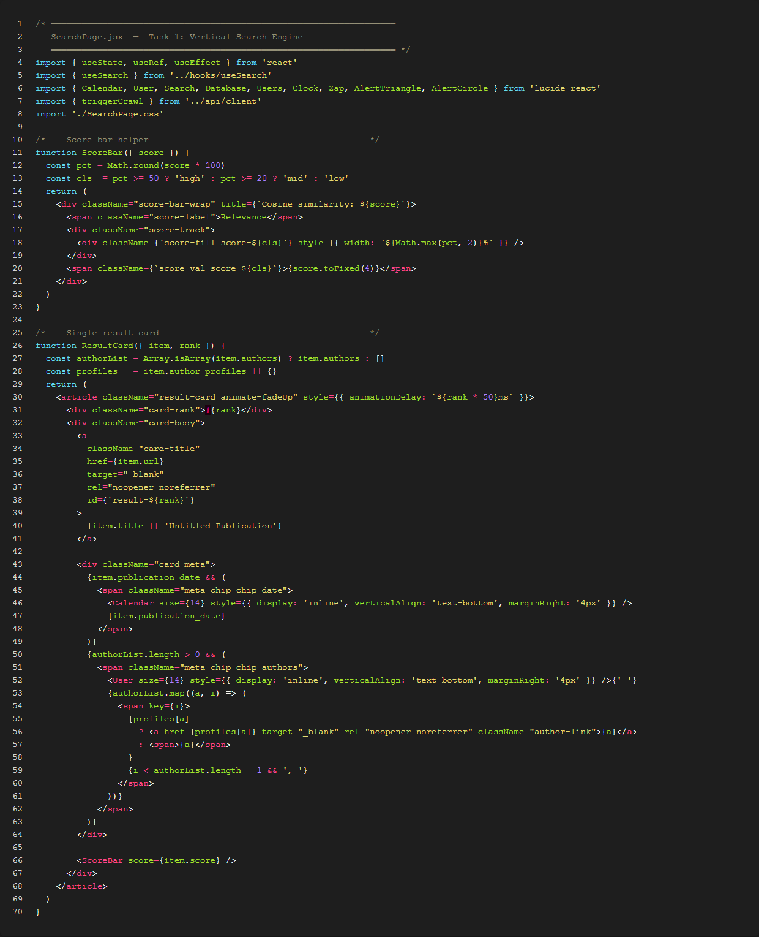

Frontend: NewsPage.jsx
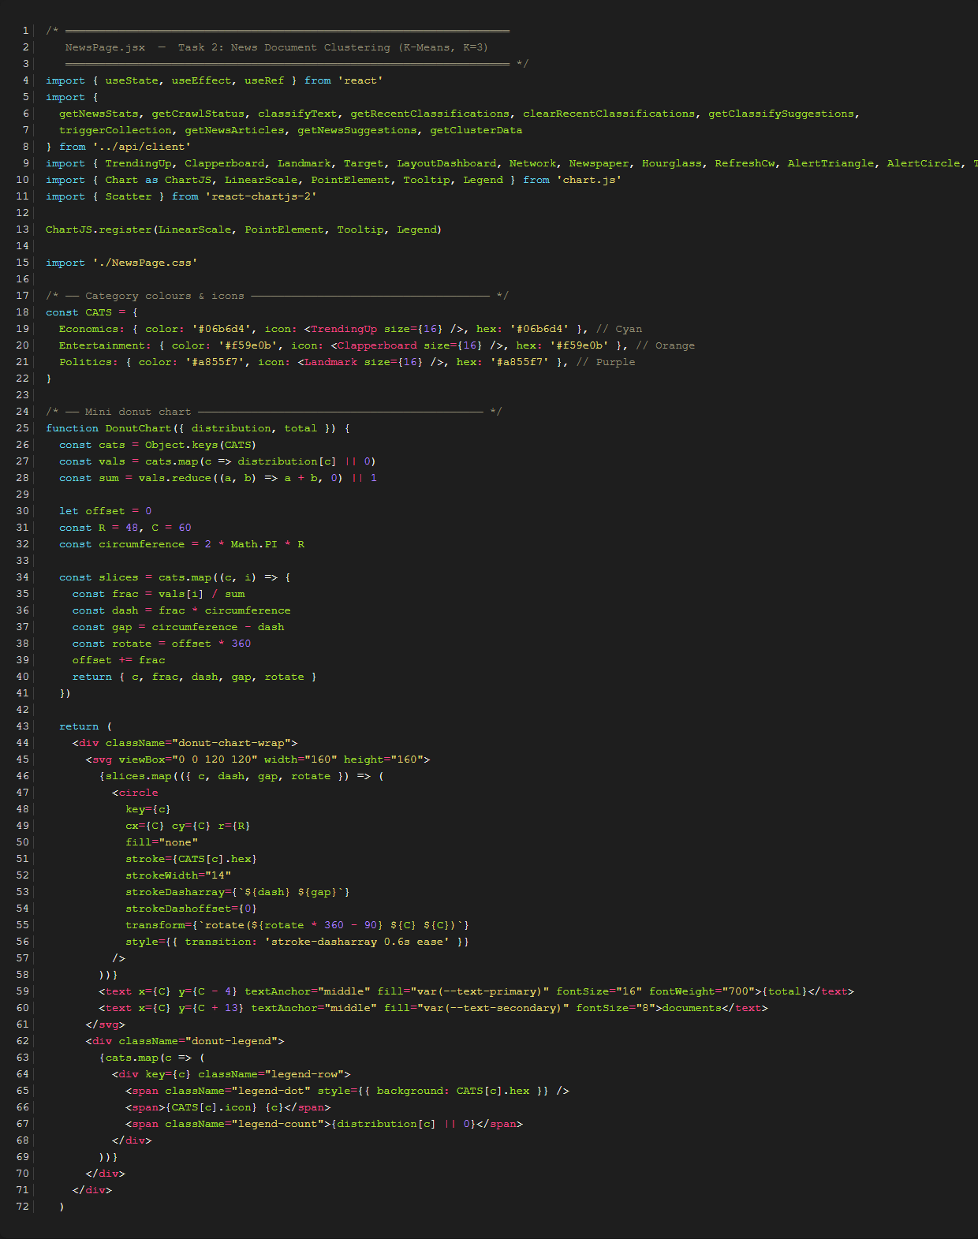

Backend: rss_collector.py (KMeans Clustering implementation)
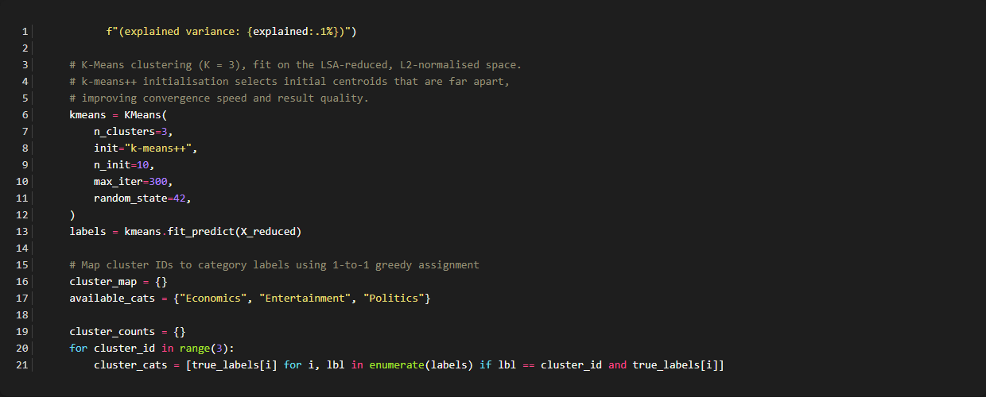

Backend: scheduler.py (Scheduler trigger implementation)
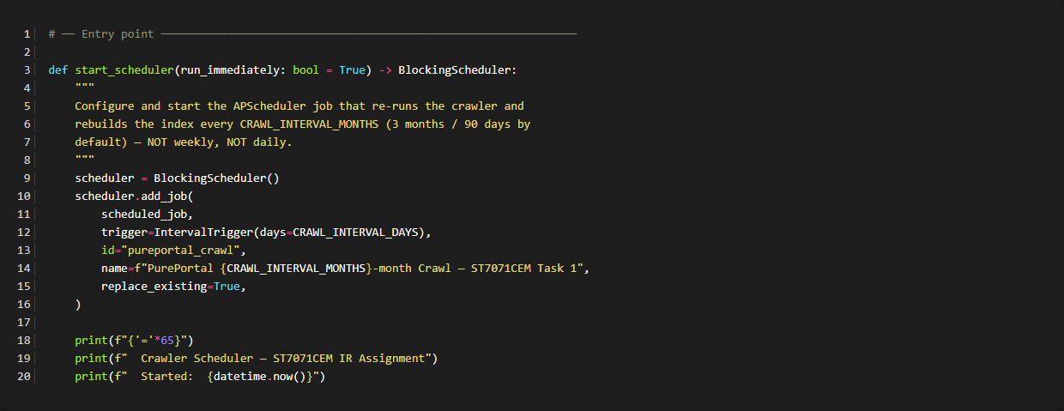

Backend: scheduler.py (Crawler Link Filtering)
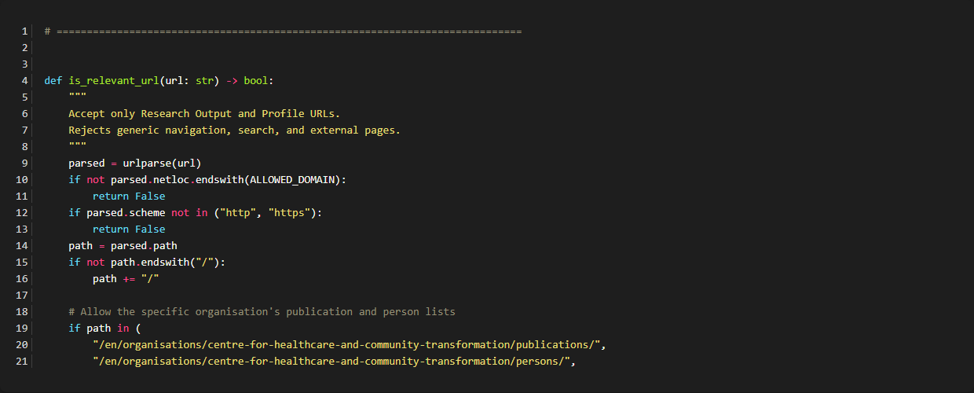

Backend: app.py (Top-K and Pagination)
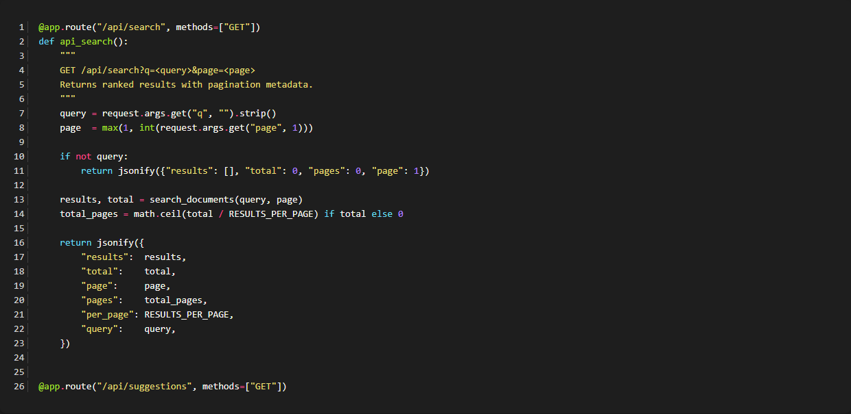

Backend: app.py (News Classification and MongoDB Storage)
